A daily Report Being Presented to the University President Regarding the University’s Constructions

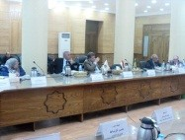
The deans’ board at the university, headed by prof.Dr. El-Sayed EL-kady, the university president, issued a bulletin that a daily report should be presented to the university president of the current and future constructions. There should be deadlines to finish these designs in “El-Obor land” or the different faculties. There also should be a plan under the supervision of prof.Dr.Gamal Ismail, the vice president to supervise the different constructions in the university according to the budget to meet the demands of the different constructions in the faculties. These bulletins were issued in the deans’ board meeting in the presence of prof.Dr.Gamal Ismail, the vice president of community service and environment development, all faculties’ deans, the university president’s chancellor of geometrical constructions and the university’s general secretary.

