Egyptian Knowledge Bank’s workshop to be held in the Faculty of Nursing

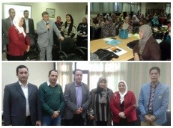
Prof. Dr. El-Sayed EL-Kady, the university president says that the students’ activities should be activated to succeed. The university president’s statement concurs with a workshop that let the researchers get to know the services of the Egyptian knowledge bank. This workshop was held in the faculty of nursing in the presence of prof. Dr. Howayda Sadik, the faculty’s dean. The university president goes on saying that the quality management system requires consistent development of the educational process to graduate efficient students who can participate in developing their own country.

