The University President discusses the Cooperation with the Chinese Forest University

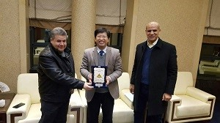
Prof.Dr. El-Sayed El-Kady, the university president and the accompanying delegation discuss the cooperation with the agricultural university in China. The university president says that the meeting is about putting the cooperation protocol into effect and enhances the cooperation between both universities in the different scientific and research fields. The university president asserts that the second international conference of the mutual cooperation in the agriculture, engineering, science and medicine will be held next October in addition to giving the armor of Benha University to the agricultural university president.

