Benha University President invites the Head of the Education Board in People’s Assembly to attend the University Forums about the Development of Higher Education and Scientific Research

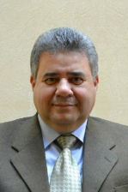
Benha university president invites the head of education board in people’s assembly prof.Dr. Gamal Shiha to attend the university forums about the Development of higher education and Scientific Research. This forum is held under the auspices of prof.Dr. Ashraf EL-Shihy, the minster of higher education and scientific research. The forum will be held in 25-2-2017.

