The Martyrs blood protects the Homeland

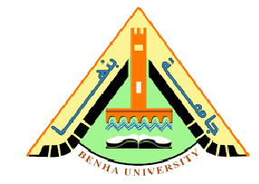
Prof.Dr. El-Sayed El-Kady, the university president, his vice presidents, the faculties’ deans, the faculties’ deputies, the faculties’ members, the university’s employees and university students were struck by the news of the mean terrorist attack on the ambush in El-Arish on Monday morning. The university leaders, on their part, were determined to face terrorism and they mourn the homeland martyrs who were martyrized for the sake of defending Egypt. May Allah have Mercy on their purified and blessed souls.

