The university president inspects the exams in the faculty and listens to the student’s suggestion about developing the curriculums

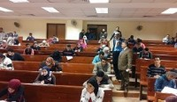
Prof.Dr. El-Sayed EL-Kady, the university president inspects the mid-semester exams in the faculties of computer and informatics, arts, and specific education as he makes sure that the exams are nicely up and running and the rules set forth by the university council was strictly-followed. He listens to the students’ suggestions to meet the demands of the labor market. These suggestions should be carefully refined and thoroughly studied by the faculties’ deans to draw the most important ones to be added to the youth forum to develop education which will be organized in next February. The university president inspects the workshops of the faculty of engineering and the medical administration.

