Benha launches a Free-Virus -C University Campaign

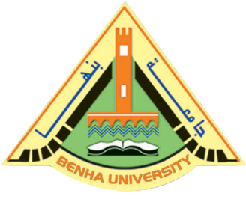
Benha university launches, headed by prof.Dr. EL-Sayed EL-kady, the university president, a campaign of a free Virus-C university in cooperation with Egypt Fund. The university president says that he meets with Mr. Muhammad Ashmawy, the Executive manager of the fund, prof.Dr. Abd EL-Moneim Badawy, the chancellor of the united Arab Bank. The meeting is held in the presence of Mrs. Manal Shahin, Mrs. Heba Hafez, and the head of programs sector, communication and media, prof.Dr. Mahmoud Abd EL-Sabour, the dean of the faculty of medicine, prof.Dr. Yosry El-Saied, the head of the hospitals and Mr. Wael Meky, the manager of public sector in the university.

