A Cooperation protocol between Benha University and Egypt Fund in the Geometrical and Scientific Counseling

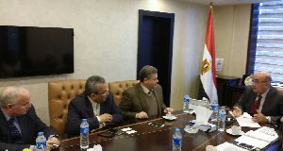
Prof.Dr. EL-Sayed EL-Kady, the university president says that there is a Cooperation protocol between Benha University and Egypt Fund in the Geometrical and scientific counseling in addition to scientific research. The cooperation protocol is signed in the presence of general / Amr Abd El-Moniem, the Qulubia Governor. The university president says that he meets with prof.Dr. Abd EL-Moneim Badawy, the chancellor of the united Arab Bank stressing that signing the protocol comes as a reward for the success and the fruitful participation of the faculty of engineering /Shubra regarding the geometrical supervision on the “Tahia Misr” City to put an end to the squatter areas. This city is one of the big projects that are established under the auspices of the president of Egypt /Abd El-Fattah El-Sisi.

