A Hearing session to develop education in Benha University

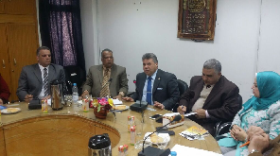
Prof.Dr. EL-Sayed EL-Kady, the university president meets the representatives of the 15 faculties’ members in a workshop to develop the education and scientific research in Egypt. The workshop is held in the presence of prof.Dr. Muhammad Abu Salim, the dean of the faculty of veterinary medicine, prof.Dr. Ezat EL-Khait, the head of the faculties’ members club and prof.Dr. Eman EL-Bitar.

