The University President meets the Faculties’ Members to discuss the Pillars of Developing Education

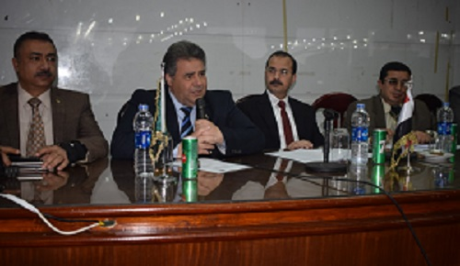
Prof.Dr. EL-Sayed EL-Kady, the university president urges that the alumni should have three main skills: languages, computers skills and communication skills. The university president stresses that the university provided low-costed courses in the languages center for the students and the faculties’ members alike. This statement concurs with the workshop that is held on Thursday, 26-1-2017. This workshop is among a group of workshops held for the first forum of the Egyptian universities to develop the educational process. This forum will be held from 22-2-2017 to 25-2-2017 under the auspices of prof.Dr. Ashraf El-Shihy, the minister of higher education, Prof.Dr. EL-Sayed EL-Kady, the university president and prof.Dr. Ibrahim Ragah, the head of the projects development unit in the university and the deputy of community service and environment development in the faculty of medicine. The workshop is attended by prof.Dr. El-Syed Fouda, the den of the faculty of law, prof.Dr Muhammad Mansur, the deputy of community service and environment development in the faculty of law and prof.Dr. Khalid Esawi, the university’s president’s chancellor of the students activities.

