“The First Day of the academic Year is a joyous day” says the University President to the Deans

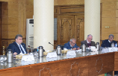
Prof.Dr. EL-Sayed EL-Kady, the university president urges the faculties’ deans that the first day of the academic year should be a day of joy and nationalism. He stresses that the patriotic songs should be broadcasted in this day and there should be a communication between the dens, the faculties’ members and the students to talk about the role of the youth in building their country.

