An Enormous Development in Benha University’s Periscopes
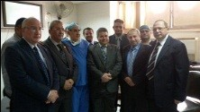
Prof.Dr. El-Sayed El-Kady, the university president heaps praise on the enormous development of the periscopes’ surgery and stresses that a great achievement has been done by conducting more than 20 operations by using the periscopes. This statement concurs with the inauguration of the activities of the round no.40 for the periscopes’ surgery that is organized by the periscopes’ unit and the surgery department in the Benha University’s hospitals. The university president is accompanied by prof.Dr. Mahmoud abd EL-Sabour, the den of the faculty of medicine, prof.Dr. Yosry EL-Saied, the general manger of Benha University’s hospitals.

