Tomorrow in Benha university… an international conference to be held to develop the training organization

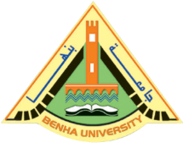
On Thursday, 8-3-2017, there is the first international conference to develop the university leaders and the training organization, the quality assurance and institutional business under the auspices of prof.Dr. EL-Sayed EL-Kady, the university president, prof.Dr. Hesham abu El-Enin, the vice president of post-graduate studies and research and prof.Dr. Gamal Ismail, the vice president of community service and environment development.

