EL-Kady from the airport to the university hospital

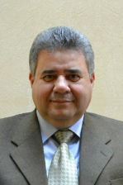
As the employees and the faculties’ members in Benha University know that prof.Dr. El-Sayed EL-Kady is in UAE, he goes to the university hospital instead of his home. The university president inspects that everything in the hospital is up and running and listens to the complaints of the nurses and promises to solve them in addition to listening to their suggestions to develop the healthcare of the patients.

.

