Benha university council discusses many important issues in its regular meeting
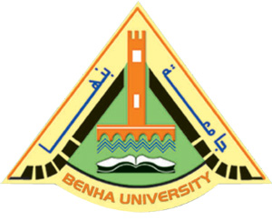
The regular meeting of Benha university council, under the presidency of prof.Dr. EL-Sayed EL-Kady, the university president, is held to discuss many important issues regarding the faculty of specific education, the faculty of applied arts and the faculty of law.

.

