“We have to pre-solve the mistakes and work as a team” says the university president to the mangers of the departments in Benha University
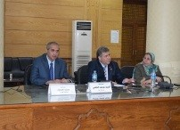
Prof.Dr. EL-Sayed EL-Kady, the university president stresses that that all visions should be thoroughly studied and the mistakes should be pre-solved. This statement concurs with the university president’s monthly meeting with the mangers of the departments in the presence of Mr. Wahid Khalawy, the general secretary of the university, the secretaries of the faculties and the general managers of the university’s faculties.

