Comprehensive convoys to be sent to El-Qulubia villages
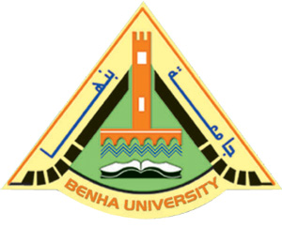
Benha University organizes a number of Comprehensive convoys which will be sent to four villages in El-Qulubia in cooperation with El-Qulubia governorate, cities councils, women’s national council and the armed forces starting from 9-4-2017 under the auspices of general / Mahmoud Ashmawy, El-Qulubia governor, Prof.Dr. EL-Sayed EL-Kady, the university president and prof.Dr. Gamal Ismail, the vice president of the community service and environment development.

