“Thank you for all the faculties because our march against terrorism has been succeeded “says the university president
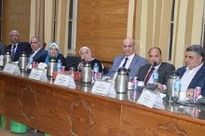
In the beginning of the meeting of the university council, prof.Dr. EL-Sayed el-kady, the university president thanks all the deans, faculty’s members and the students as our march against terrorism has been succeeded.

