“The controls are strictly run lest the students’ results are not just” says the university president

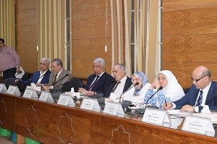
Prof.Dr. El-Sayed El-kady, the university president says, in the beginning of the leaders’ council, that the university’s faculties should strictly run the controls and makes sure that faculties’ members and teaching assistants should be on time lest the students’ final results are not just.

