Benha University’s council congratulates Magraby on being a member in the international council in the veterinary medicine

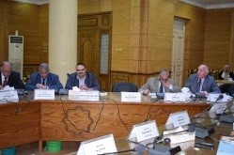
Prof.Dr. El-Sayed El-kady, the university president, in the university’s council, congratulates prof.Dr. Hussien Magraby on being a member in the international council in the veterinary medicine

