A Green Chemistry forum to be held in Benha

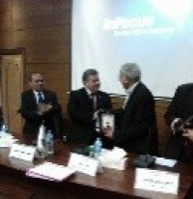
Prof.Dr. EL-Sayed EL-Kady, the university president inaugurates the first scientific forum of green chemistry which is organized by the faculty of science and it is attended by several scientists in the field of chemistry from many Egyptian universities, such as Cairo University, Ein-shams University, El-Monifya University, Helwan University and the national center of researches. After his word, Prof.Dr. EL-Sayed EL-Kady, the university president honors five scientists in the field of chemistry by giving them the armor of Benha University as follows: prof.Dr. Muhammad Youssef EL-Kady, prof.Dr. Saad Hasan, prof.Dr. Mahasen Saad Amin, prof.Dr. Galal EL-Gemiey and prof.Dr. Farouk Fahmy. The forum is attended by prof.Dr. Abd EL-Azim Mehna, the faculty&#39;s dean and prof.Dr. Alaa Amin, the head of chemistry department and the rapporteur of the forum.

