Benha University holds the second international Egyptian-Chinese conference next October

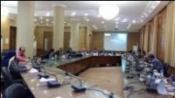
The responsible committee, which organizes the second international Egyptian-Chinese conference that will be held next October under the auspices of prof.Dr. EL-Sayed EL-Kady, the university, will hold its first meeting under the presidency of prof.Dr. Hesham Abu EL-Enin, the vice president of post-graduate studies and research in the presence of the dean of the following faculties; agriculture, veterinary medicine, engineering/ Benha, engineering/ Shubra in addition to the university president chancellors of scientific research , international relationships and the members of the executive committee.

