Establishing a branch of the faculty of education in Shibin El-kantar

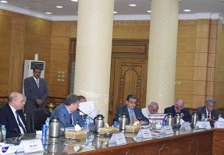
The committee of the educational studies sector of the supreme council of the universities has approved, in its meeting which was held on Saturday, to establish a branch of the faculty of education in Shibin El-kantar. The supreme council of the universities has approved on the request of Qulubia governorate representatives to set up the faculty in order to serve the inhabitants of Shibin El-kantar and the surrounding villages.

