The faculty of engineering welcomes its new dean

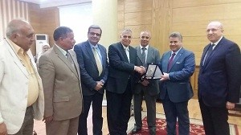
Prof.Dr. EL-Sayed EL-Kady, the university president, in the meeting today, congratulates prof.Dr. Ragab Megahed, the new dean of the faculty of engineering. The university president thanks prof.Dr. Ahmed Maged, the acting dean for the efforts he exerts for one year. The university president gives prof.Dr. Ahmed Maged the armor of the university in appreciation of his efforts.

