Spreading Awareness among employees to pay attention to the Strategic plan of Benha University

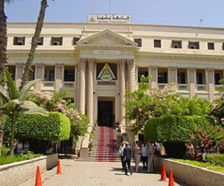
Benha University’s council, under the presidency of prof.Dr. El-Sayed El-Kady, the university president, approves on the report of prof.Dr. Gamal Abd EL-Aziz, the head of strategic planning unit in the university. This report is about holding forums to spread awareness among the employees to pay attention to the importance of the strategic plan of Benha University. These forums will begin in next September.

