The dean of the faculty of medicine inspects the university hospitals
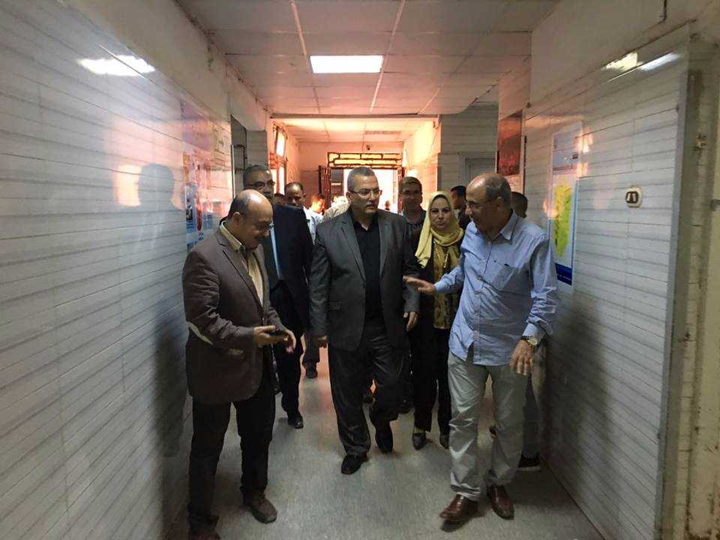
According to the university president’s instructions to declare the emergency status in the university hospitals during the feast, prof.Dr. Mahmoud Abd EL-Sabour, the dean of the faculty of medicine conducts a tour in the university hospitals with the faculty’s deputies and the heads of the departments to make sure that everything is up and running.

