El-kady inspects eight faculties in the first day of the academic year
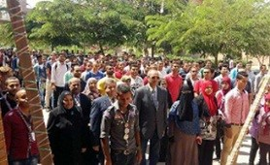
Prof.Dr. EL-Sayed El-Kady, the university president goes on a tour in a number of faculties including; the faculty of agriculture, the faculty of veterinary medicine, the faculty of computer and informatics, the faculty of applied arts, the faculty of nursing, the faulty of education, the faculty of engineering and the faculty of science. He also visits the new buildings at the services compound, the exams building, the new building of the faculty of physical education to make sure that everything is up and running and the faculties are prepared to welcome the new academic year.

