Benha University launches the fourth phase of livestock project tomorrow
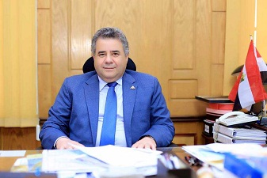
Benha University launches the fourth phase of livestock project tomorrow that is carried out by the faculty of agriculture in cooperation with bank Misr for development. This project includes distributing 390 rabbits and hens at the cost of one million and half pounds. This phase will be launched in the presence of Prof.Dr. EL-Sayed EL-Kady, the university president, colonel, Mahmoud Ashmawy, the Qulubia governor, a number of the parliament representatives , the representatives of bank Misr for development and several faculties’ deans.

