A workshop to be held in the faculty of medicine on how to win the faculties’ members competition
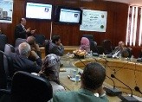
According to the university’s council decree No.153 in 19-9-2017, the competition of the faculties’ members links has been launched. And there is a workshop that has been held in the faculty of medicine on Wednesday, 11-10-2017 in cooperation with prof.Dr. Mahmoud Abd EL-Sabour, the dean of the faculty of medicine. This lecture was delivered by prof.Dr. Muhammad Ghanem, the vice CEO of information technology.

