A workshop to be held to get training on how to use the information sources in the Egyptian knowledge bank
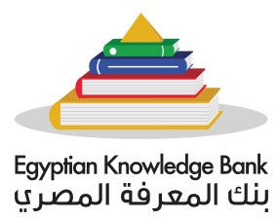
Under the auspices of prof.Dr. EL-Sayed EL-Kady, the university president and prof.Dr. Hesham Abu EL-Enin, the vice president of post-graduate studies, the general administration of the libraries in Benha University in cooperation with the digital library in the supreme council of universities hold a workshop to get training on how to use the information sources in the Egyptian knowledge bank in 17/18-10-2017 at 9:30 a.m. in the conference hall.

