EL-kady hails Benha university students and the members of the presidential initiative of the innovation
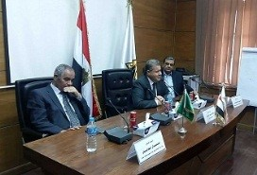
Prof.Dr. EL-Sayed EL-Kady holds a meeting in the presence of the vice presidents, the faculties’ deputies, the faculties’ members and the heads of the departments and he discusses the results that the Benha university students achieved in the presidential initiative of the technological innovation. This event is attended by university president, the President, the prime minister, other ministers and the universities presidents.

