“The Egyptians are untied and no one can separate us apart” says EL-Kady in Benha Church
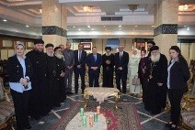
Prof.Dr. EL-Sayed EL-kady, the university president, prof.Dr. Hesham Abu EL-Enin, the vice president of post-graduate studies, prof.Dr. Gamal Ismail, the vice president of community service and environment development, prof.Dr. Hala Zayed, the dean of the faculty of computer and informatics, prof.Dr. Abeer EL-Rabat, the dean of the faculty of arts, Mr. Wahid Khalawy, the general secretary of university, Madam.Faten Kharboosh, the head of the university president office visit Benha church where they meet Mr. Machismos, the priest of Benha church. Prof.Dr. EL-Sayed EL-Kady says that the The Egyptians are untied and no one can separate them apart.

