The veterinary medicine faculty post-graduate exams are set in 2-12-2017
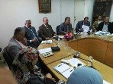
The council of the veterinary medicine faculty approves, under the presidency of prof.Dr. Muhammad Abu Salim, the faculty’s dean, on the timetable of the post-graduate studies that has been proposed by prof.Dr. Mahmoud Abu EL-Roos, the faculty’s deputy of post-graduates studies. The council decides that the exams should begin in 2-12-2017 and end in 19-12-2017.

