EL-Kady’s interview on “Sada-El-Balad” Channel
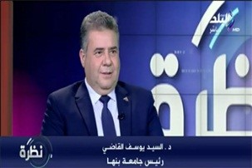
“Sada-El-Balad” Channel hosts Prof.Dr. EL-Sayed EL-Kady, the university president in “Nazra” program that is moderated by Mr. Hamdy Rizq on Thursday, 2-11-2017 to discuss the war on corruption in Benha university and the services that Benha university provides to the public.

