The leaders’ council approves on EL-Kady’s suggestion to offer 100 scholarships to Africa
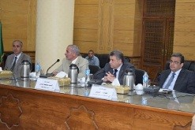
Benha University’s leaders council approves, in its meeting under the presidency of Prof.Dr. EL-Sayed EL-Kady, on the university’s president suggestion to offer 100 free scholarships which is afforded by Benha University to Africa. These scholarships comes in accordance with Egyptian president‘s orientation toward the African continent and reinforcing the relationships with the continent’s countries.

