The faculty of veterinary medicine’s teamwork for the Brucella project
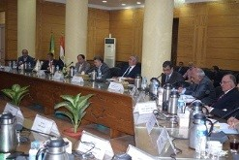
Benha University’s leaders council approves, in its meeting under the presidency of Prof.Dr. EL-Sayed EL-Kady, on the bulletin of the department’s council of the faculty of veterinary medicine to form Brucella controlling project. This project is conducted in cooperation with scientific research and technology academy and the European Union under the presidency of prof.Dr. Muhammad Abu Salim, the faculty’s dean and the membership of prof.Dr. Shawky Mustafa, prof.Dr. Gamal Warth, Miss, Afaf EL-Mihy and Mr. Salah Farahat.

