A professor in Benha University gets the fund of the National Natural science foundation of China

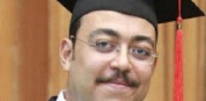
Prof.Dr. Muhammad Farahat Fouda, the lecturer at the biochemistry department in the faculty of agriculture gets the fund of the National Natural science foundation of China in order to fund the researches of the young foreign researchers in 2017.

