The heads of quality management centers in the Egyptian universities are welcomed in Benha University in 27-11-2017
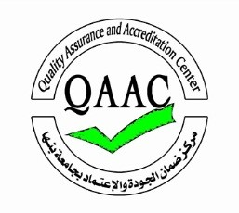
Benha University hosts the fifth meeting of the heads of quality management centers in the Egyptian universities. This event is organized by the national authority of quality assurance and accreditation center and it is entitled “the impact of the accreditation in higher education institutes” on Monday, 27-11-2017 in the university council hall.

