“We aspire to have qualified graduates for the labor market” says El-kady in the meeting of quality assurance units managers
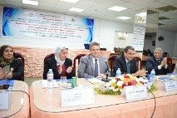
Prof.Dr. EL-Sayed EL-Kady, the university president stresses that the Egyptian universities are considered the home of experience and the communities have to make use of them. The universities have to serve the community and the Egyptian universities aspire to have qualified graduates for the labor market and the community needs.

