EL-Kady and Ashmawy inaugurate Benha university products exhibition
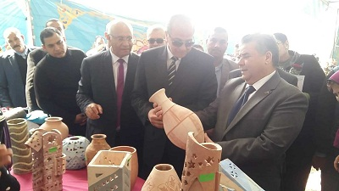
Prof.Dr. EL-Sayed EL-Kady and general/ Mahmoud Ashmawy inaugurate Benha university products exhibition which include the products of the faculty of agriculture, the faculty of veterinary medicine, the faculty of science, the faculty of specific education and the faculty of applied arts in addition to the products of the “Muslim youth” assembly that hosts the exhibition.

