A forum to be held at the faculty of education about citizenship and loyalty in the school of “Emyay/ Toukh”

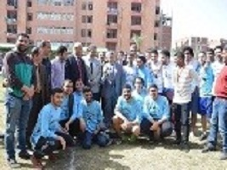
The faculty of education organizes, under the auspices of prof.Dr. El-Sayed EL-Kady, a forum in the school of “Emyay/ Toukh”. This forum is attended by prof.Dr. Gamal Ismail and several faculties’ members in the faculty. The forum discusses many topics, like citizenship and loyalty of the youth.

