
Benha University
Benha Higher Institute of Technology

Department of Mechanical Eng.
Subject : Turbo machines Date: 17/1/2011

Model Answer of The Final Exam
Elaborated by: Dr. Mohamed Elsharnoby
المادة : ألات تربينية
1-a) Fan is a machine imparting only a small pressure rise to continuously flowing gas; usually the density ratio across the fan is less than 1.05 such that the gas is considered to be incompressible. While the density ratio across the compressor exceeds 1.05 and the flow should be considered as compressible one.
ii) Impeller is the rotating member in the centrifugal pump or compressor; but the runner is the rotating part in radial flow hydraulic turbine or pump.
iii) Both diffuser and draught tube are passages that increases in cross-sectional area in direction of fluid flow so that they converts the kinetic energy into static pressure head. While the diffuser is usually situated at the outlet of a compressor; the draught tube is usually situated at the outlet of a hydraulic turbine.

b) The power dimensionless specific speed, Nsp, is found by eliminating the diameter D from the power and head coefficients.
The power and flow coefficients are respectively given by:$\bar{P}=P/{\text{ρN}}^{3}D^{5}$ , $ψ=\text{gH}/N^{2}D^{2}$so we get $N_{\text{sp}}={\bar{P}}^{1/2}/ψ^{5/4}={\text{NP}}^{1/2}/ρ^{1/2}(\text{gH})^{5/4}$.Figure 1 shows a typical hydraulic turbine runner shapes for different specific speeds along with their optimum or design efficiencies. Its observed that Pelton is used for low specific speed , Francis turbine for moderate specific speeds and axial flow turbine for high specific speeds.
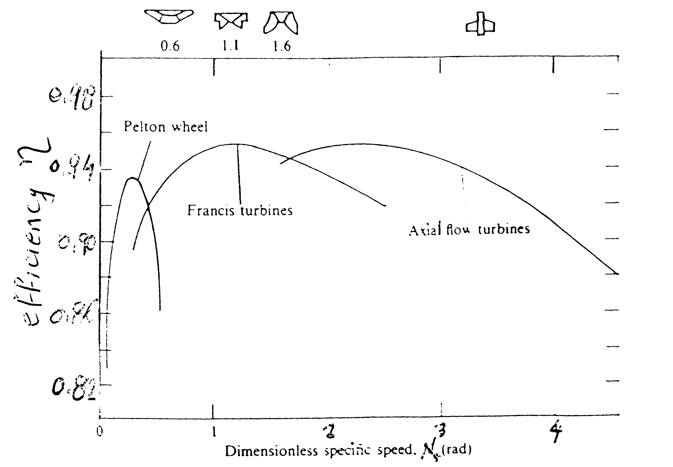
Fig.1 Variation of hydraulic turbine runner design with dimensionless specific speed.
1-c) Assuming dynamic similarity exists between the firdt and second sized pumps, we equate the flow coefficients. Thus

From Fig.2 at Q₁ = 2.83 L/s and 2000 rpm the head H₁ is 14 m and equating the head coefficients for both cases gives,
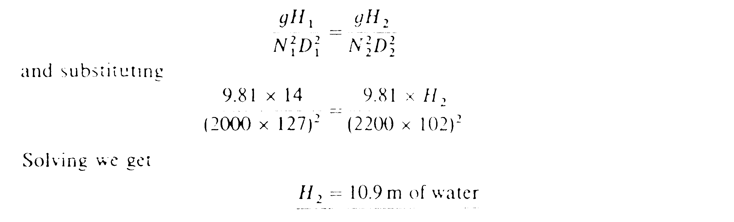
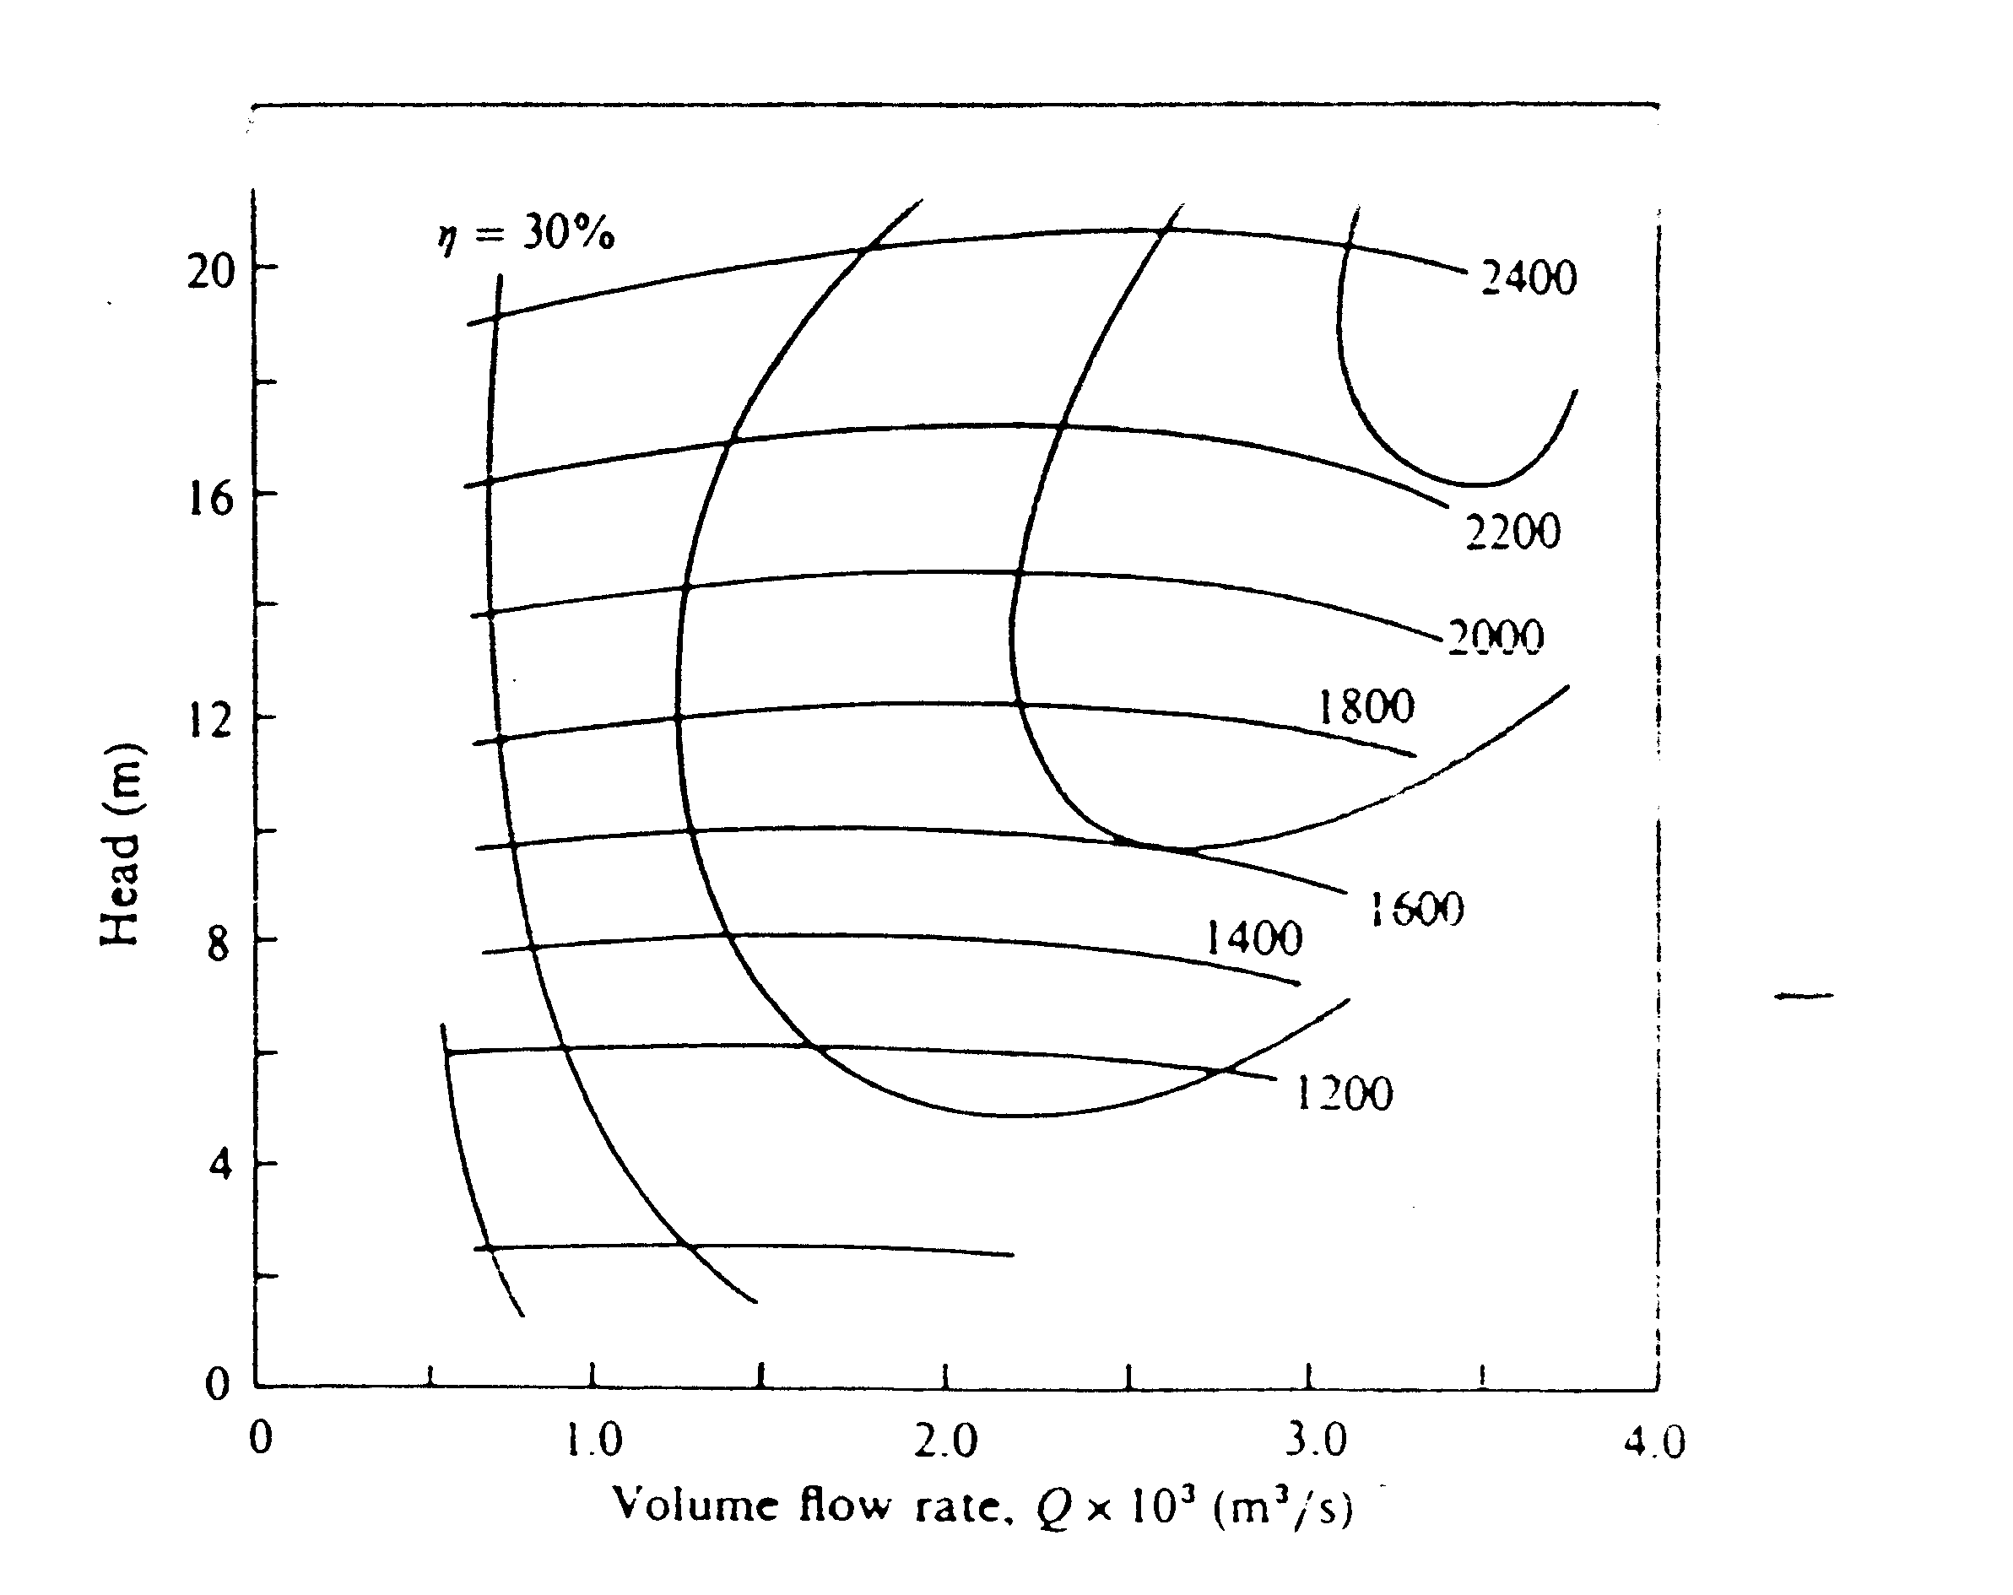
Fig.2
2-a) A typical pumping system is shown in Figure 3 where
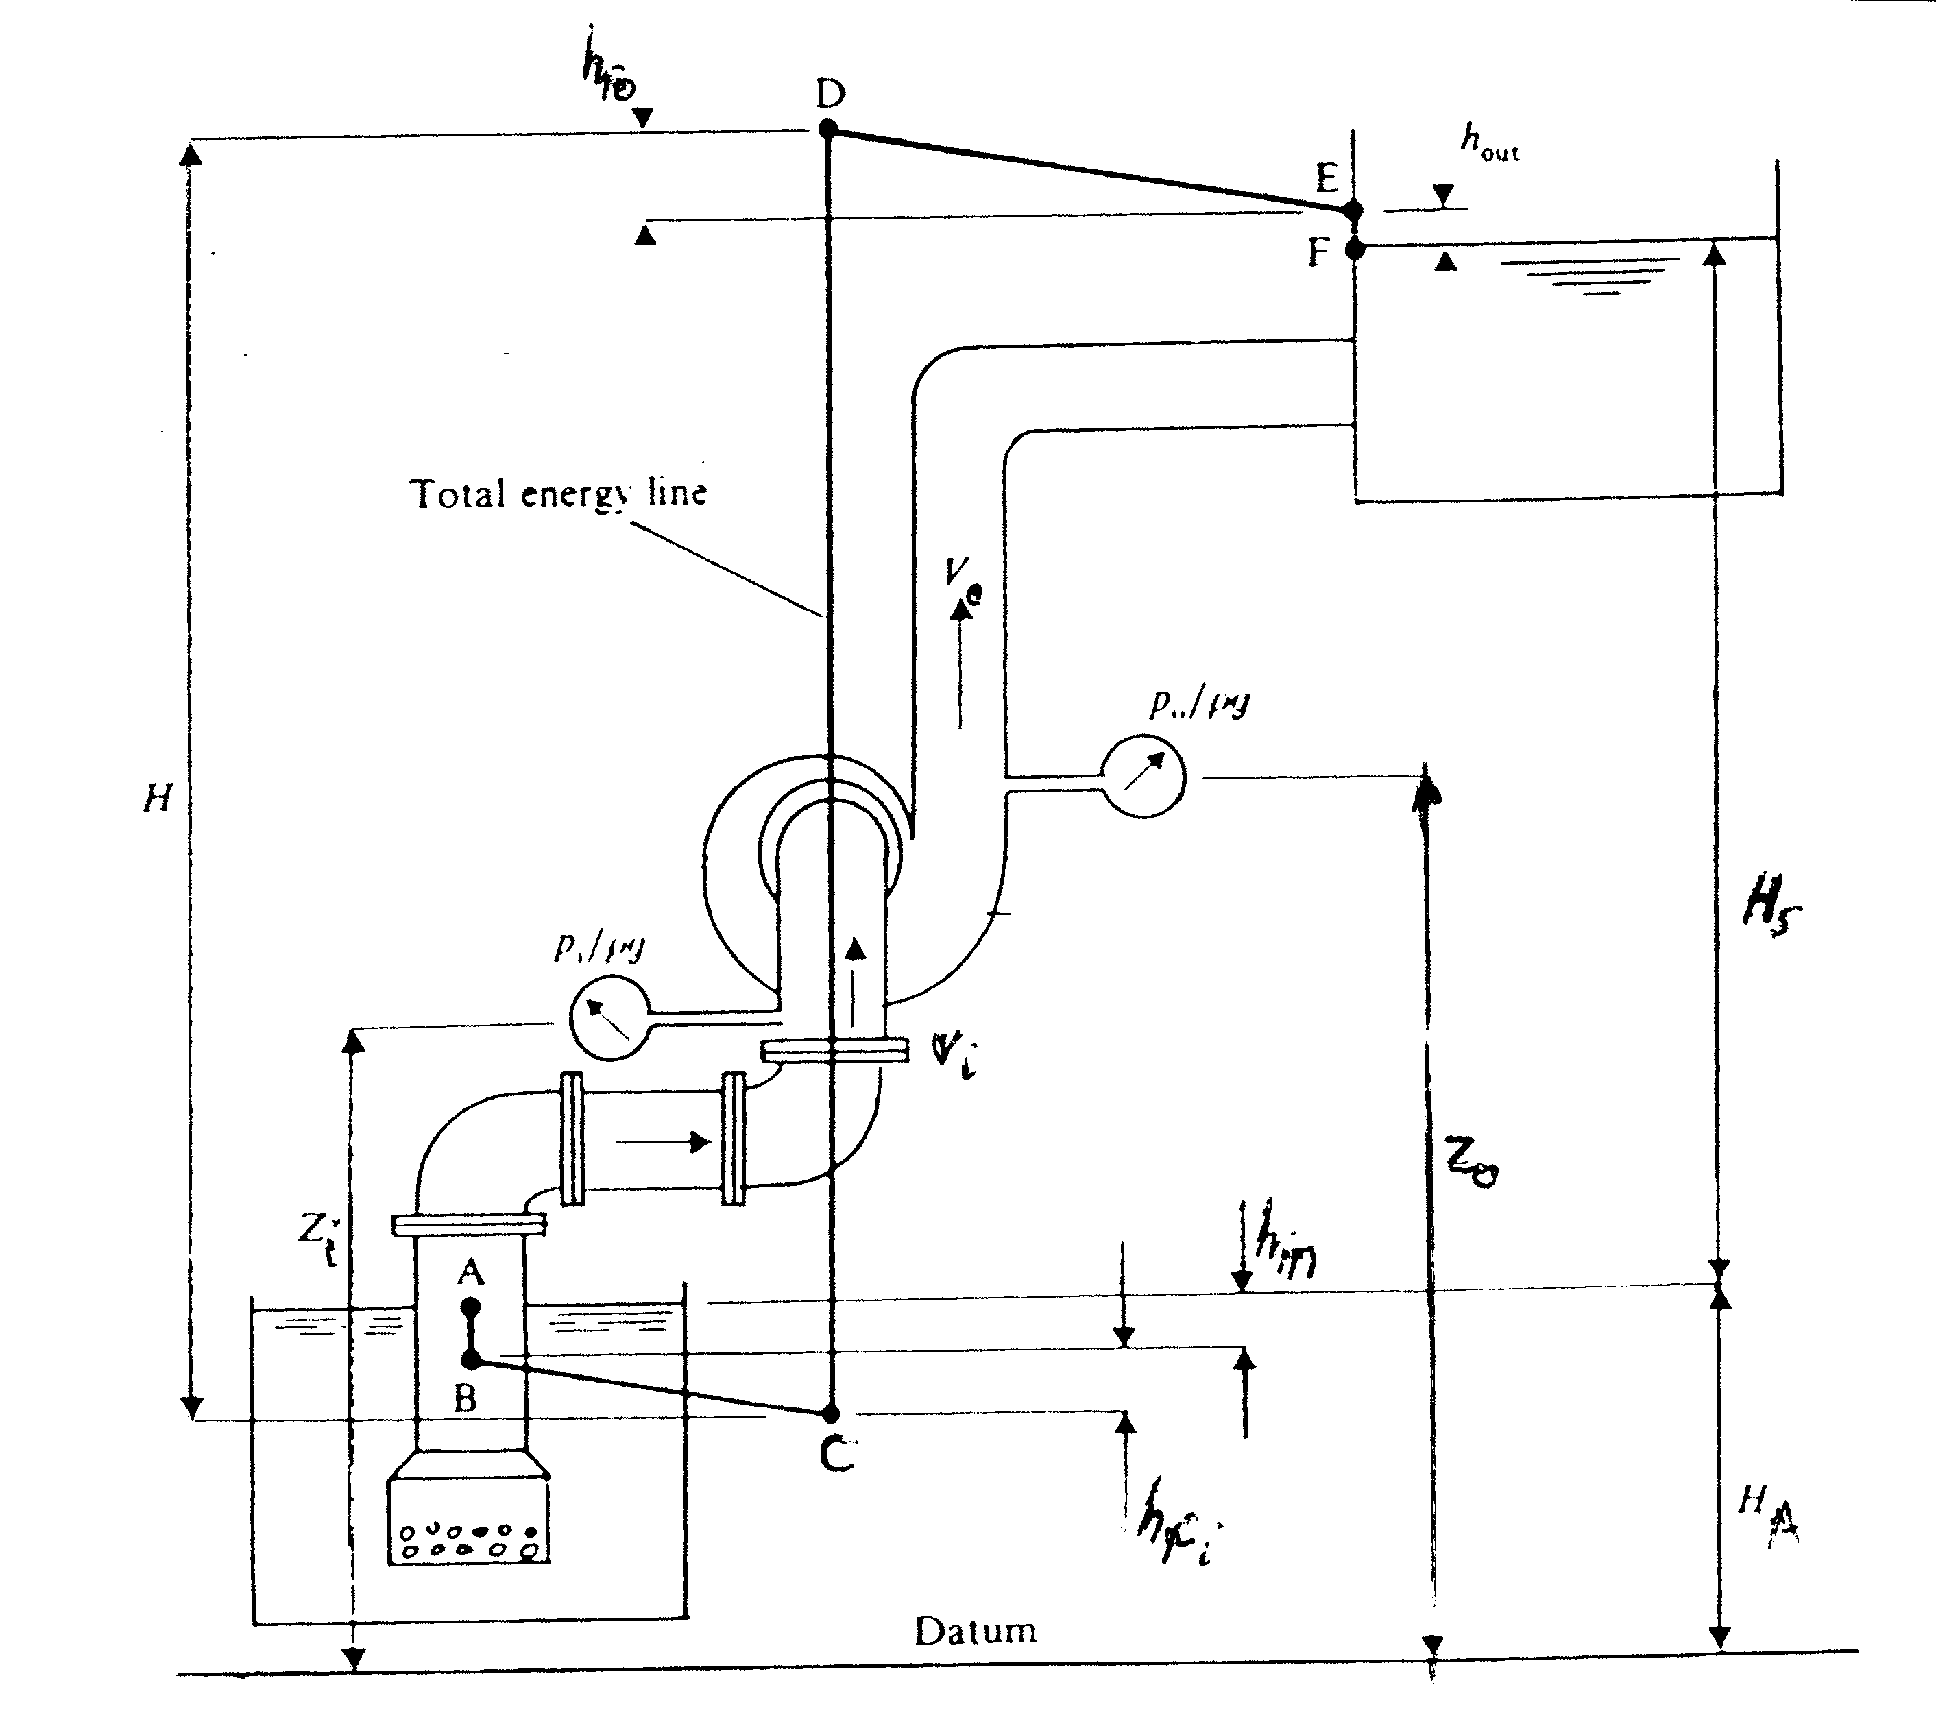
Figure 3. Pumping system
b) the dependence of pump characteristics on blade outlet angle $β_{2}$are shown on Figures 4 and 5.
Figure 4 shows the theoretical dependence between the energy head and the flow rate Q which is given by the equation $E=U_{2}^{2}/g−({\text{QU}}_{2}{\text{cotβ}}_{2}\text{/gA})$
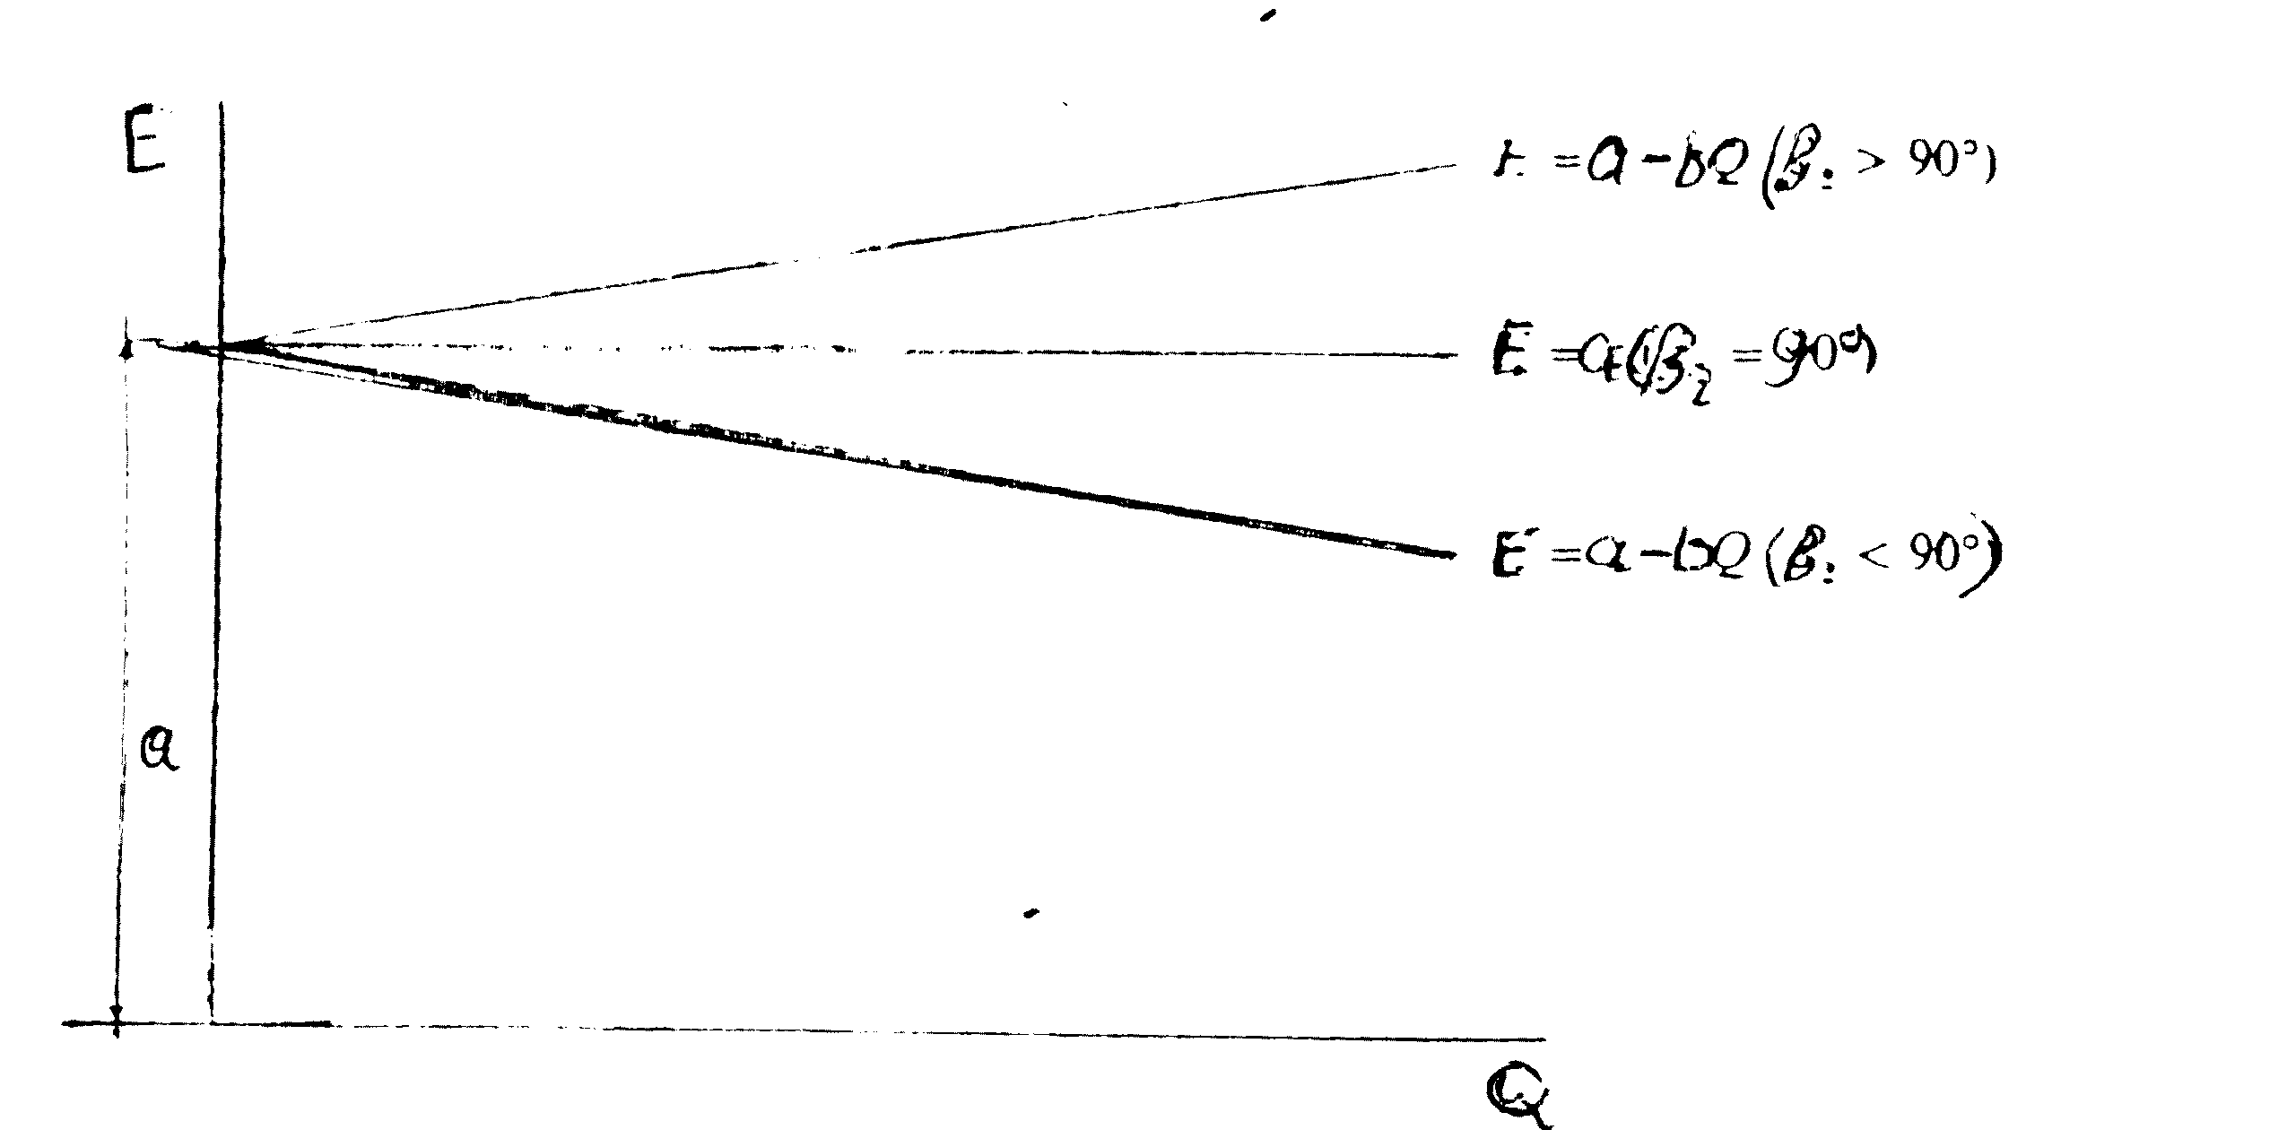
Figure 4 : Theoretical characteristics for varying blade outlet angle

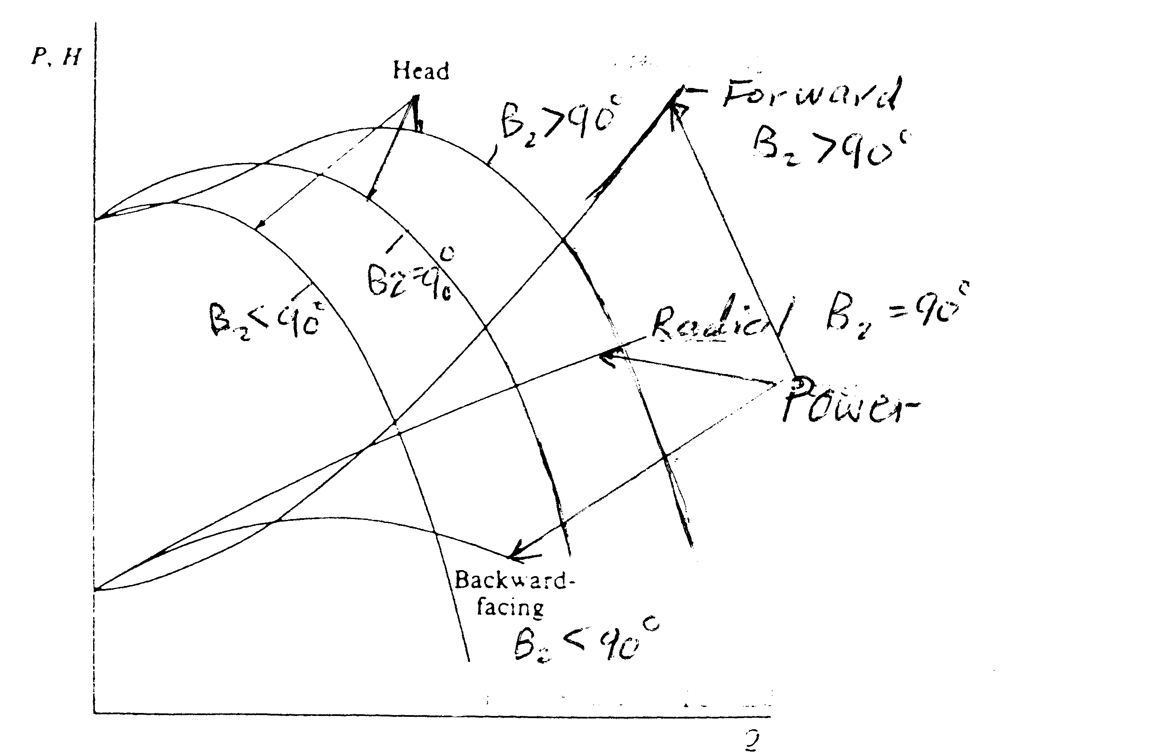
Figure 5 Actual characteristics for varying blade outlet angle
Figure 5 shows the actual dependence of power and head on the flow rate for different $β_{2}$.
c) The single pump characteristic is plotted in the figure below along with the characteristics for the two pumps connected in series and in parallel. Since the same pump is used in both cases ; for the series connection the flow rate is the same and the head is doubled while for the parallel connection the head across the pump is the same and the flow rate is doubled. 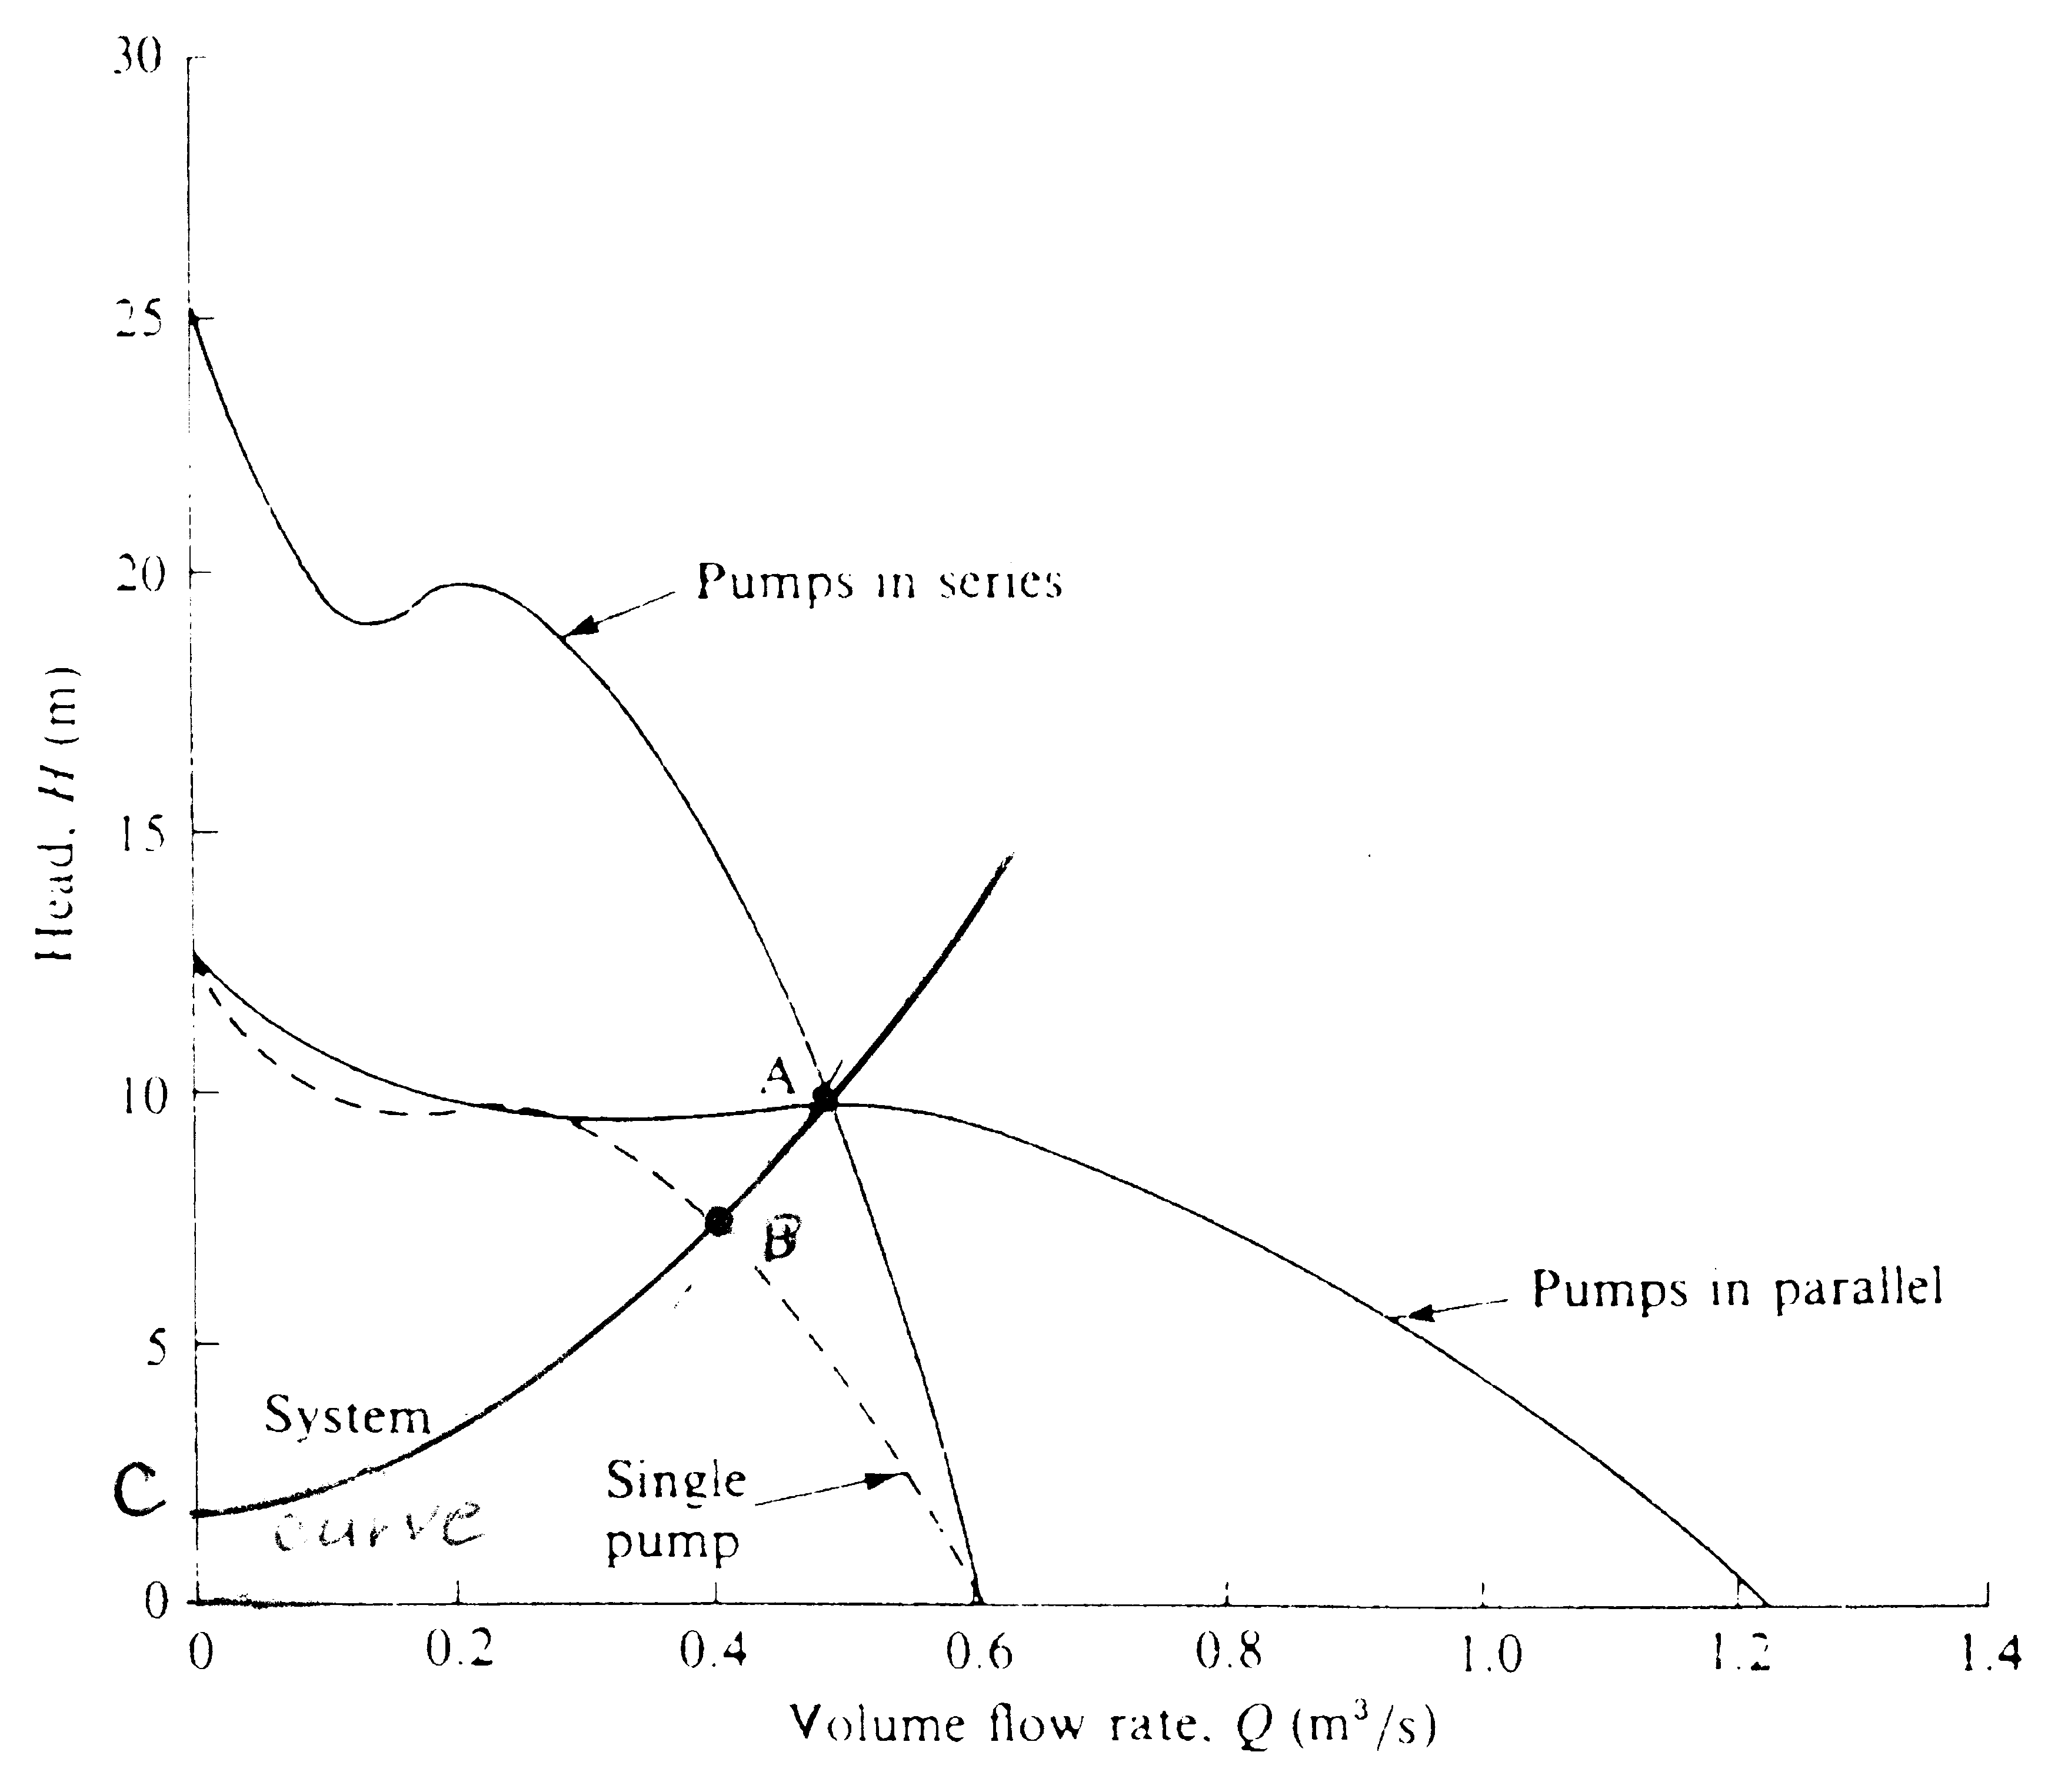
Figure 6: Axial pump characteristics when connected in parallel and series.

Series connection
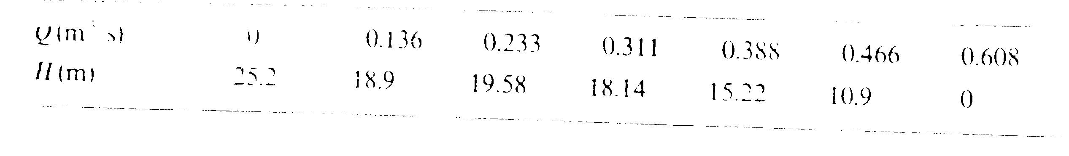Parallel connection
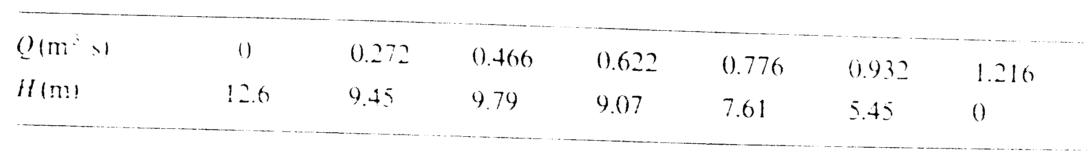At point A both connections give the same head and flow rate and the system characteristics must pass through this point and the point C(0.2) since there is 2m static lift.
At operating point A in the above figure
Q = 0.48 m³/sec, H = 9.75
For the system curve H = H_{s} + K Q²
But H_{s} = 2 , therefore H = 2 + 0.48² K = 9.75
And then K = 33.64
Hence the system curve is given by :
H = 2 + 33.64 Q²
The system curve is parabolic and may be drawn for various flow rates and head as shown in the above figure. The point B is the operating point for a single pump within the system.
The single pump operates at point B :
Q = 0.4 m³/sec
H = 7.4 m

3-a) Figure 7 illustrates the system with the velocity triangles.
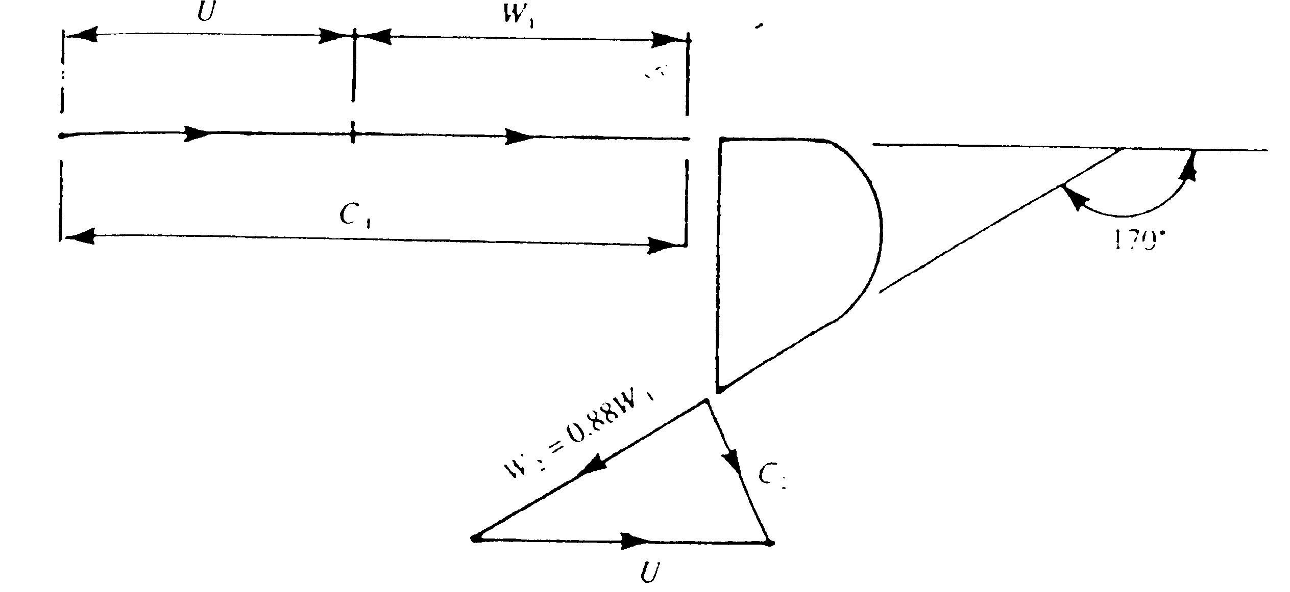

Figure 7 Inlet velocity triangle
The hydraulic efficiency is given by:
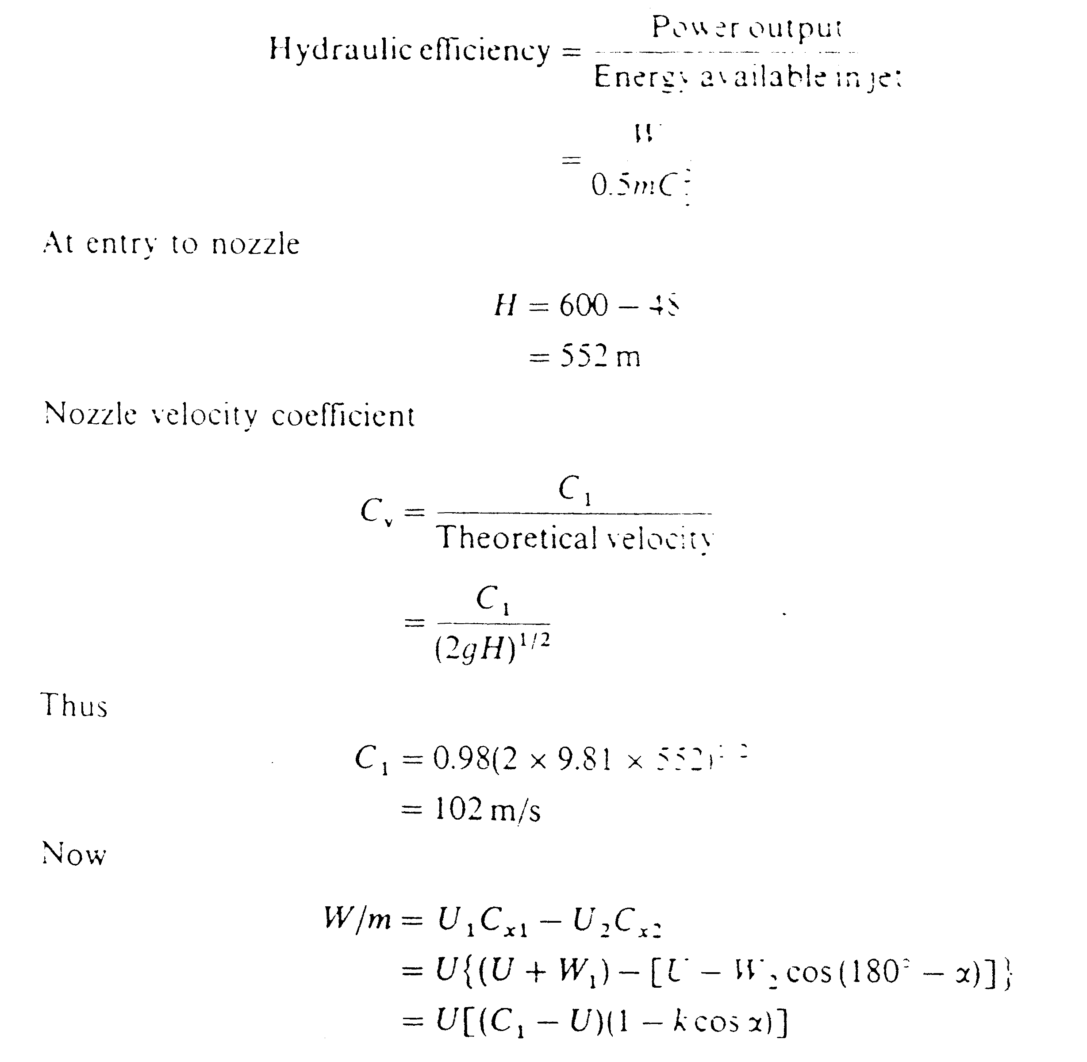
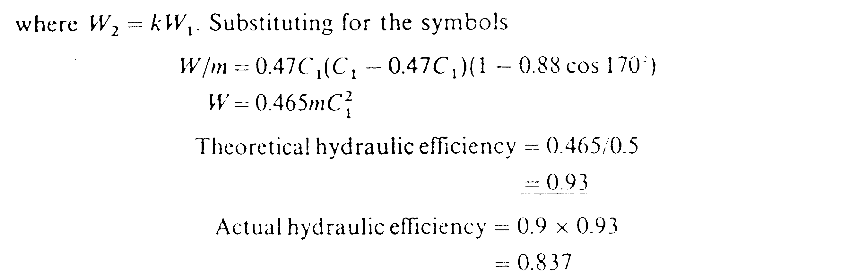
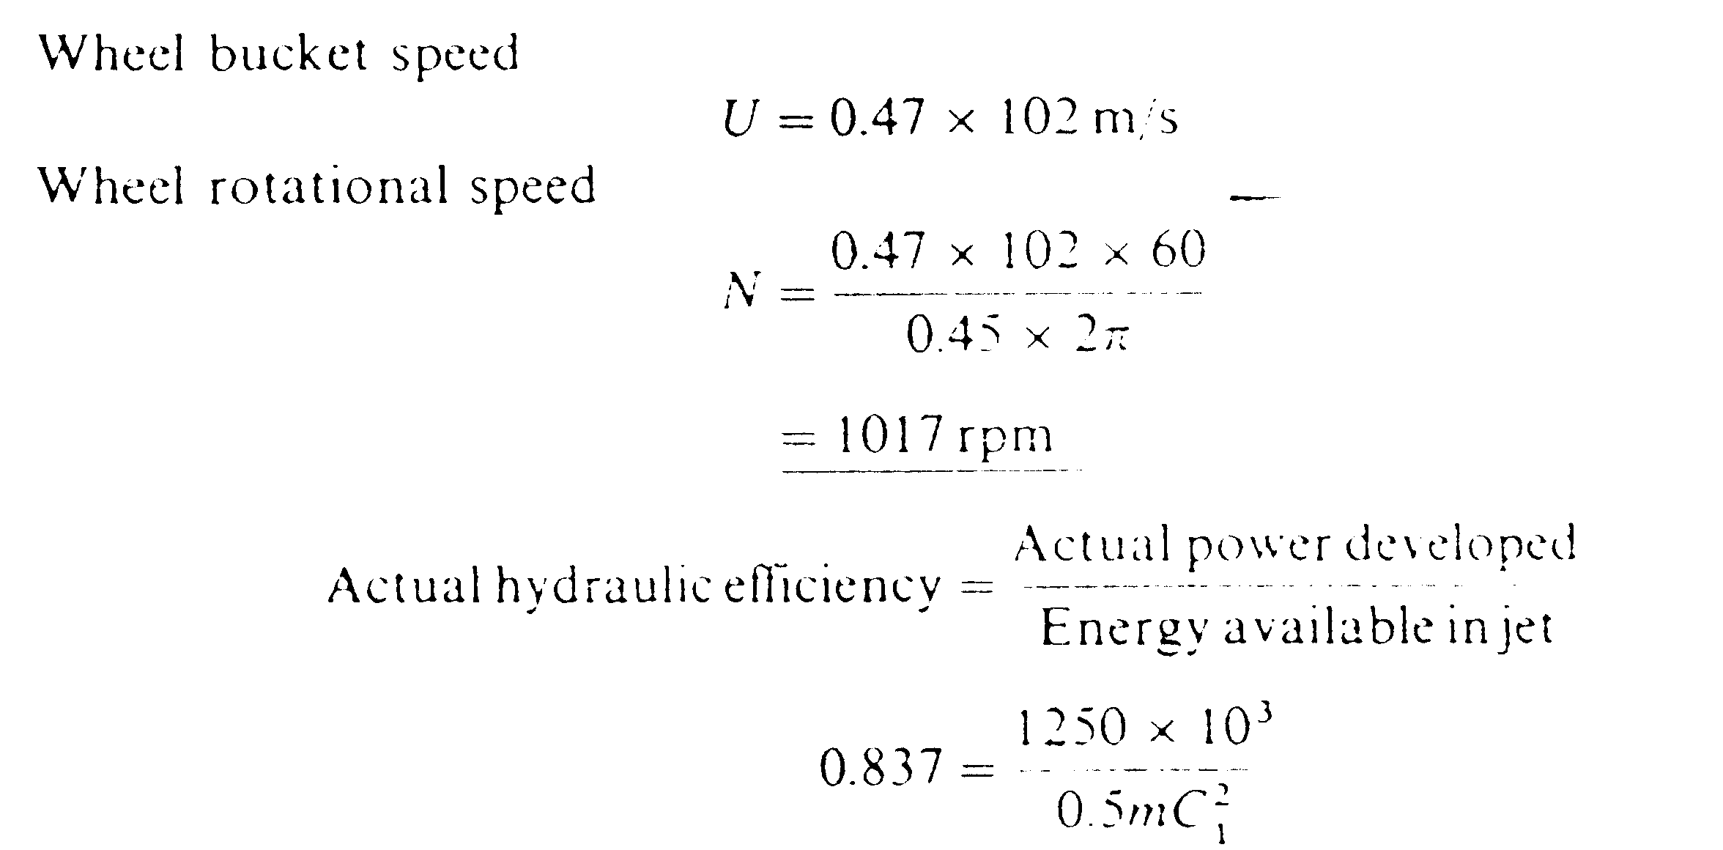
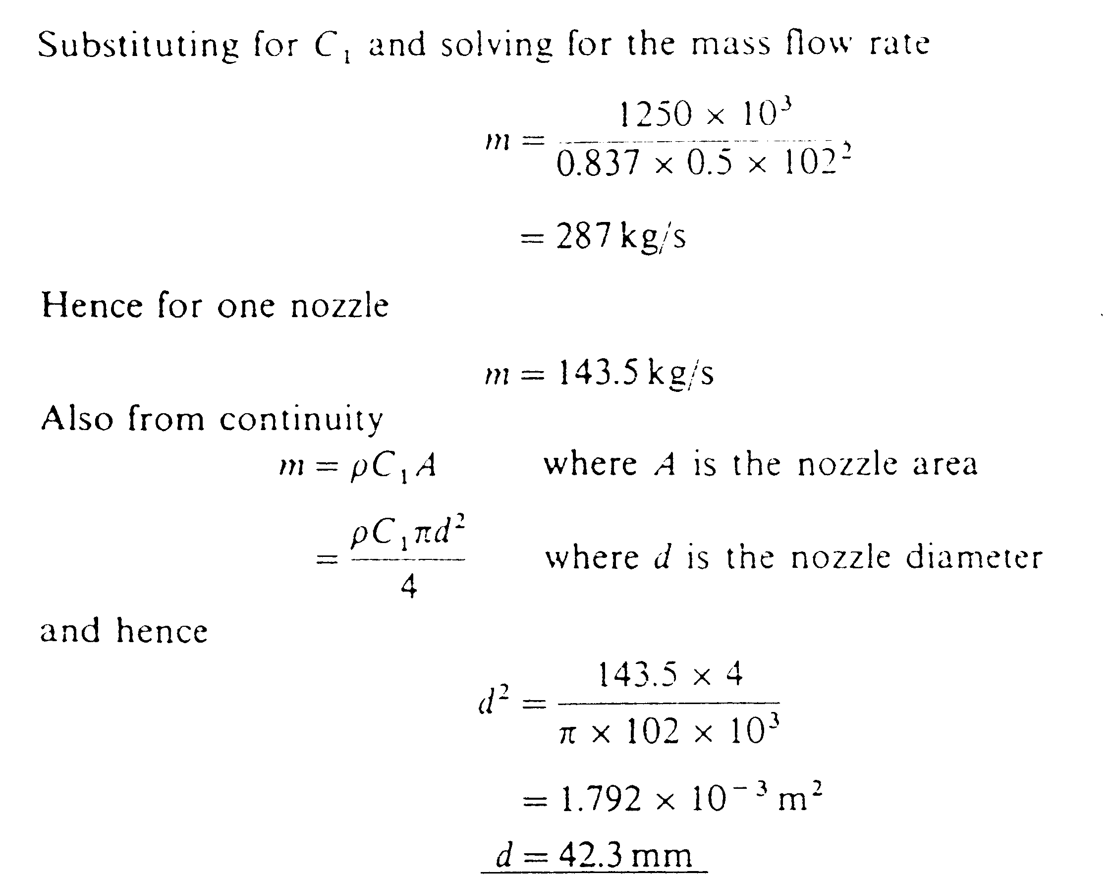

3-b)The hydraulic efficiency is given by
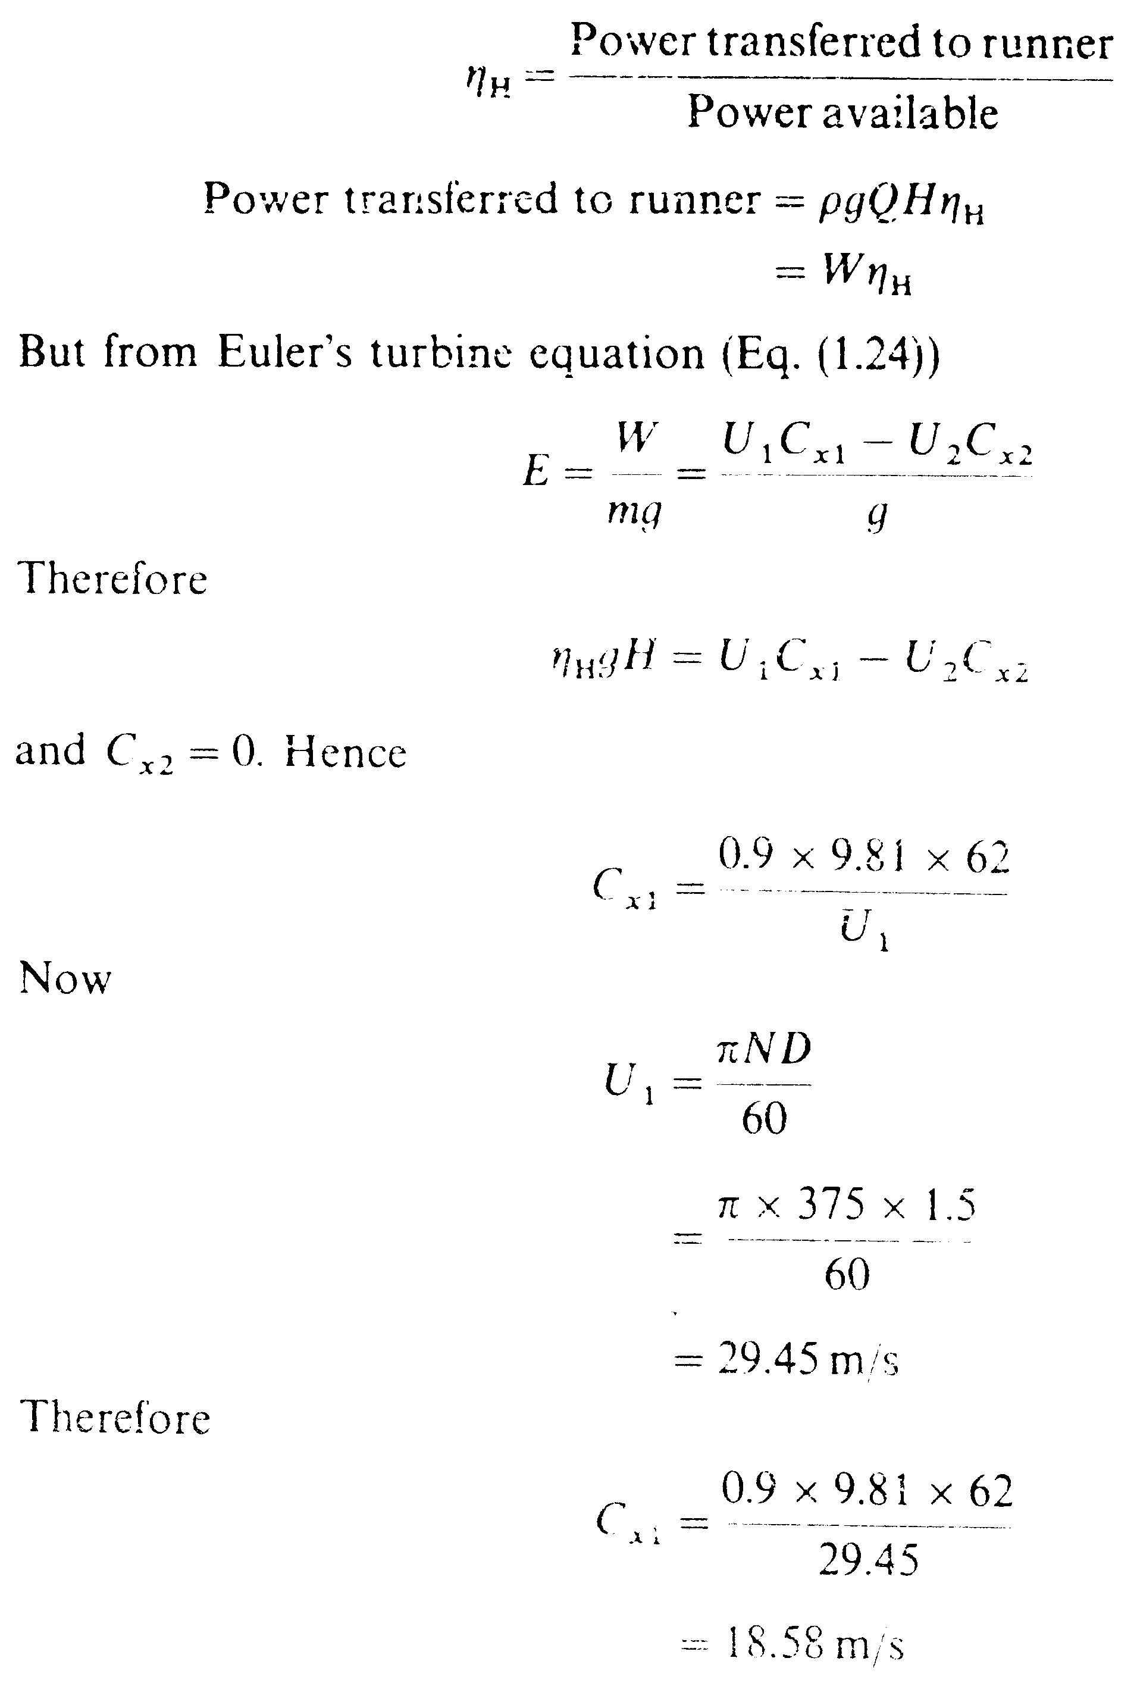

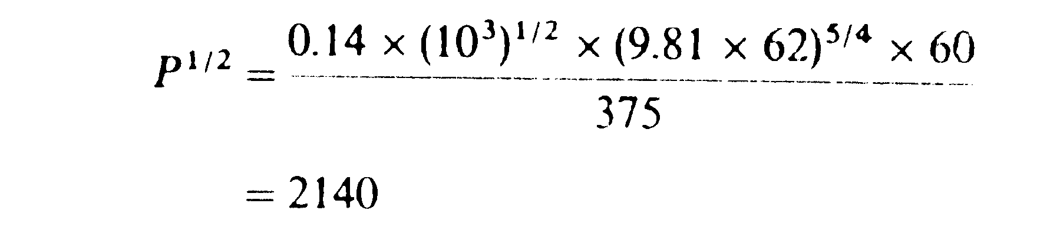
P = 4578 kW (this power is delivered to runner)
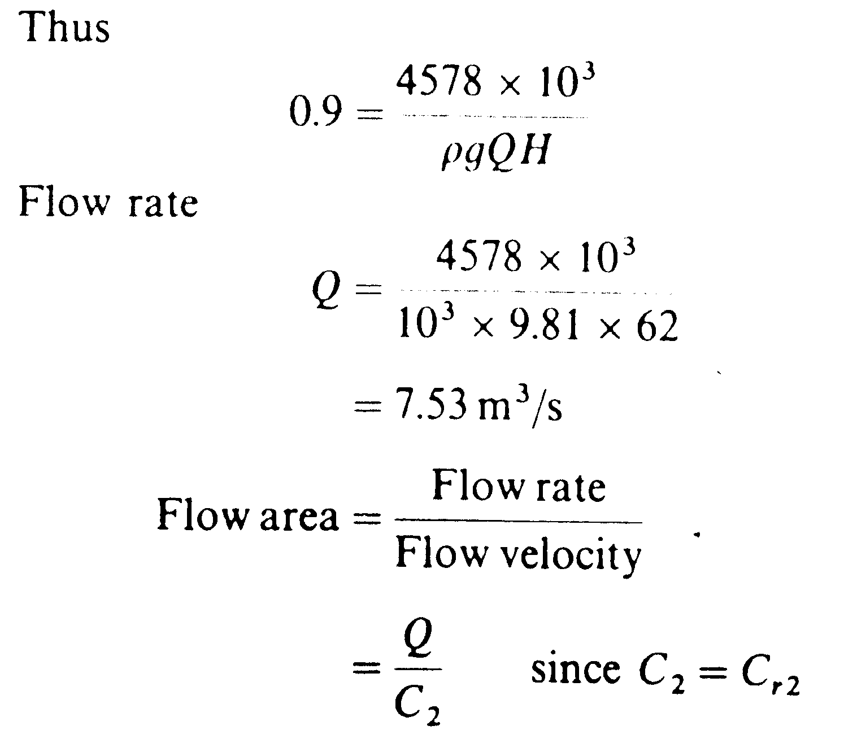
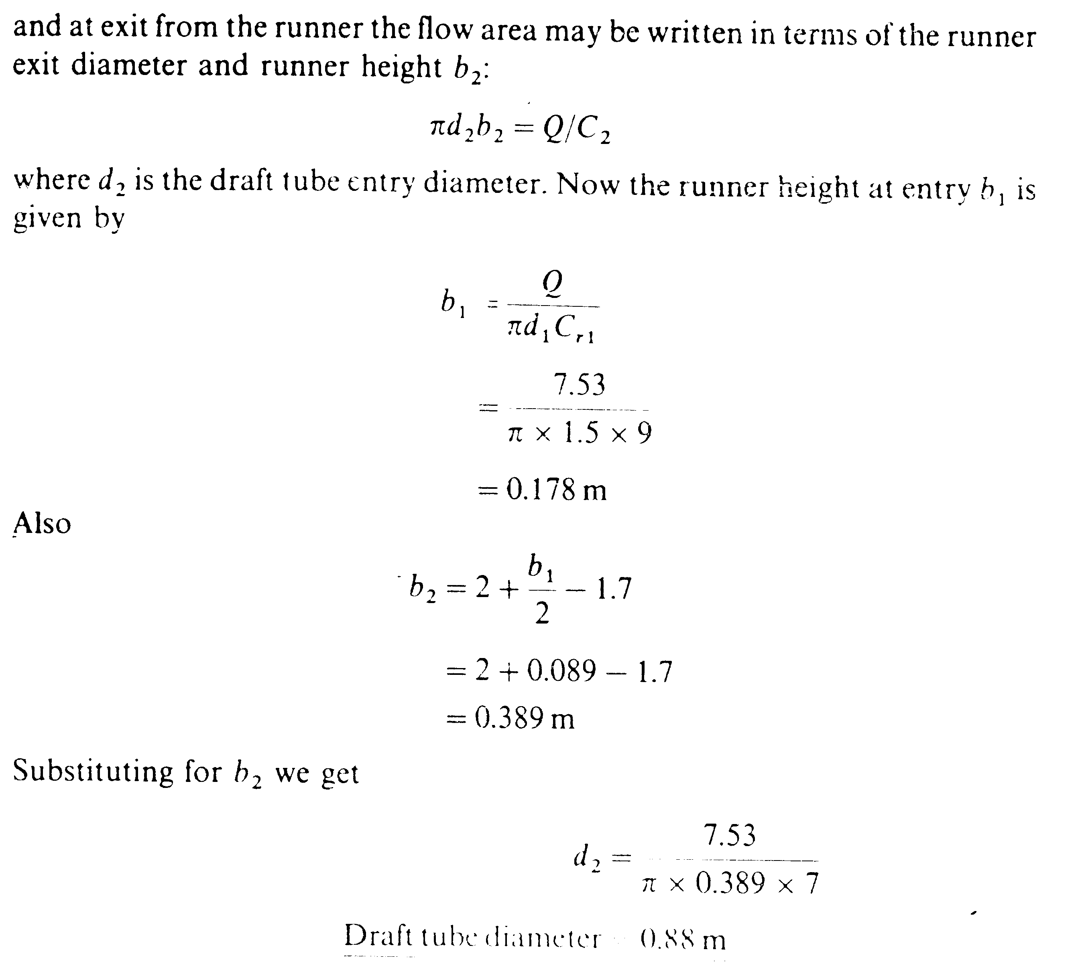

4-a) b) Figure 8 illustrates the change in total pressure loss coefficient and mean deflection on changing the angle of incidence i
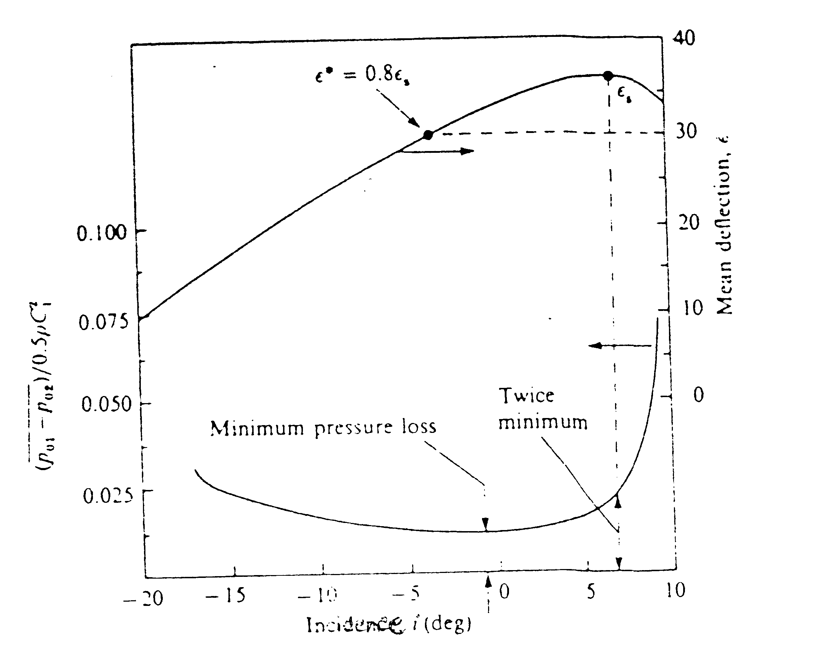
Figure 8 : cascade mean deflection and pressure loss curves.

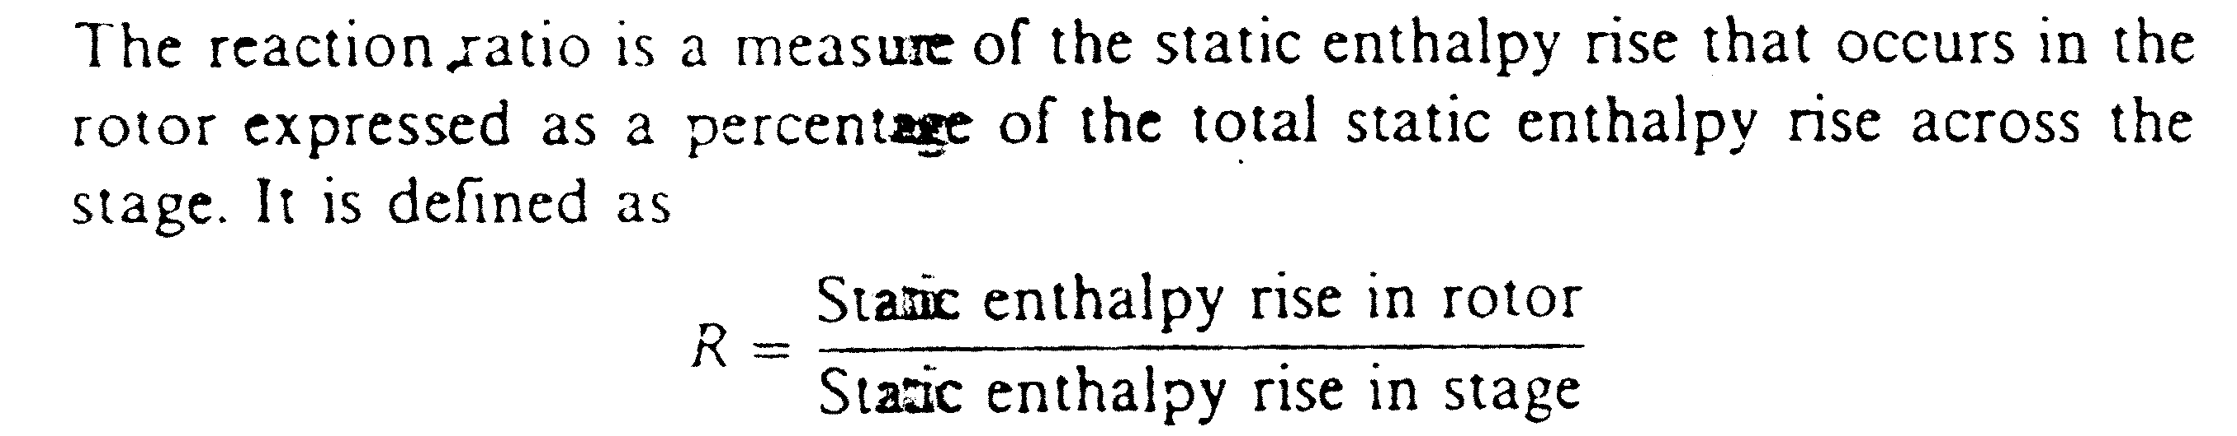
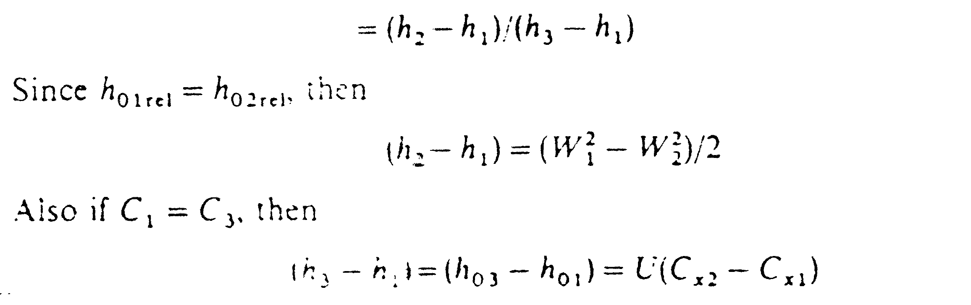
And substituting for (h₂-h₁), (h₃-h₁), the reaction ratio R becomes
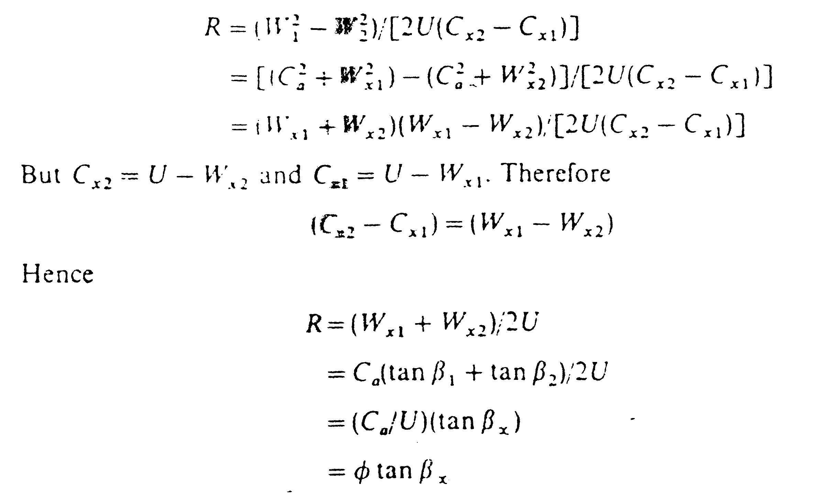
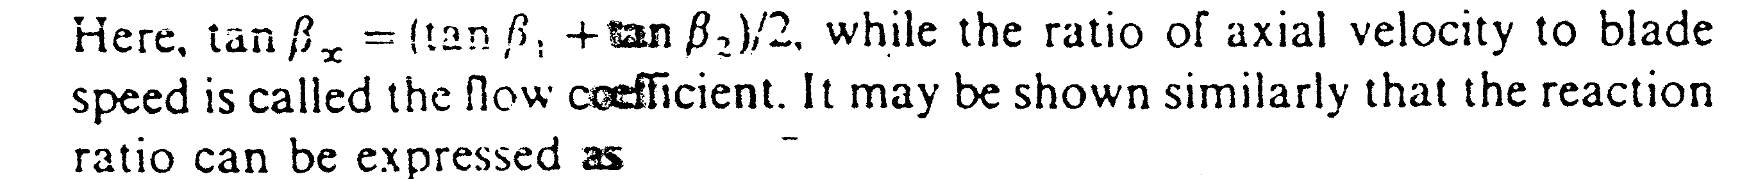
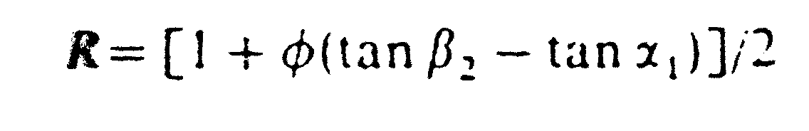
b) The inlet Mach number should be restricted to an acceptable value . It may be achieved by placing guide vanes at the inlet . Guide vanes at the inlet will impart a whirl component C_{x1} to the fluid, thus reducing W₁ to an acceptable value. This is shown in the figure 9 below.
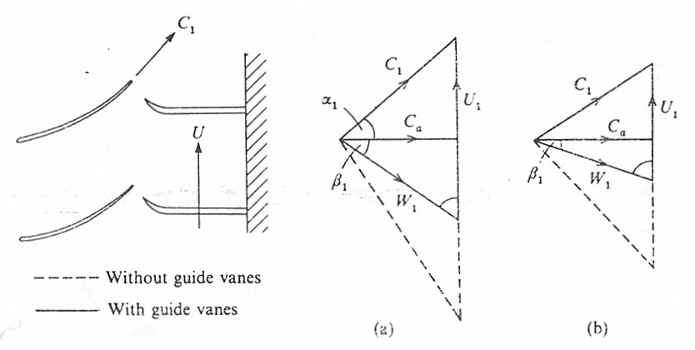

Figure 9: The effect of inlet guide vanes on the inlet relative velocity: (a) at shroud; (b) at hub

4-c) The diagram temperature difference is
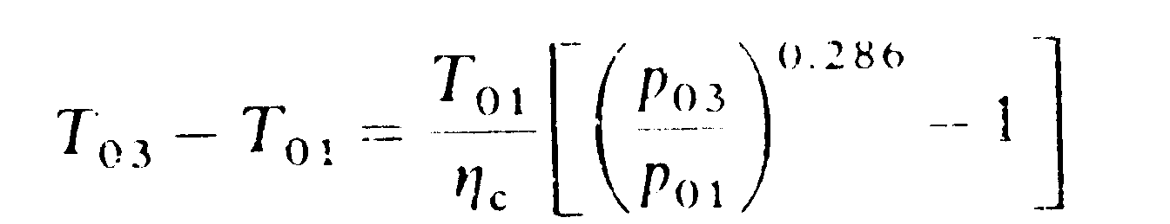\
= 167.2 degree
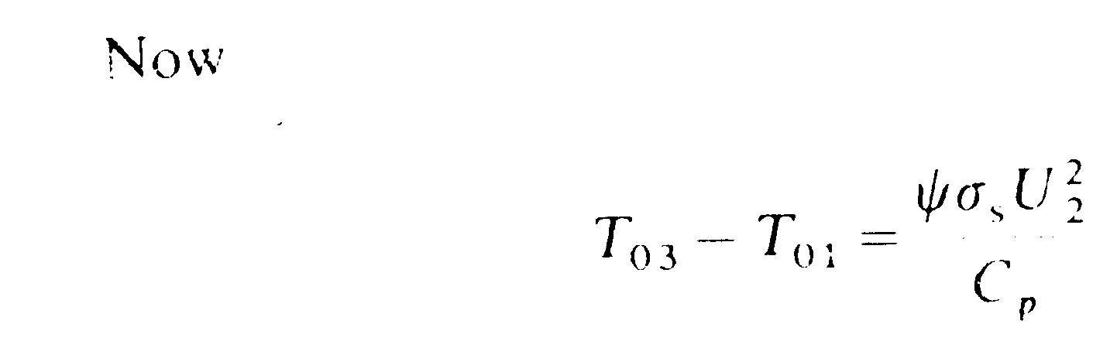
Therefore U₂ = 425.75 m/sec
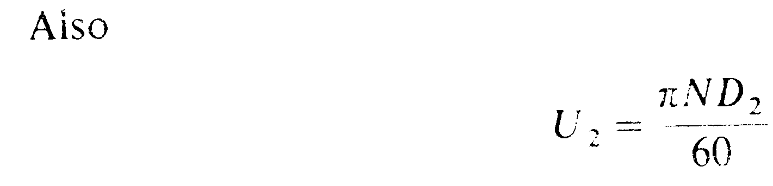
D₂ = 0.6776 m
The impeller diameter is equal to 0.6776 m
The overall loss is proportional to (1-η_{c}) =(1-0.8). Half of the overall loss is therefore 0.5(1-0.8) = 0.1 and therefore the effective efficiency of the impeller in compression is (1-0.1) = 0.9.

= 4.35
T_{o2} = 288 + 167.2 =455.2 K
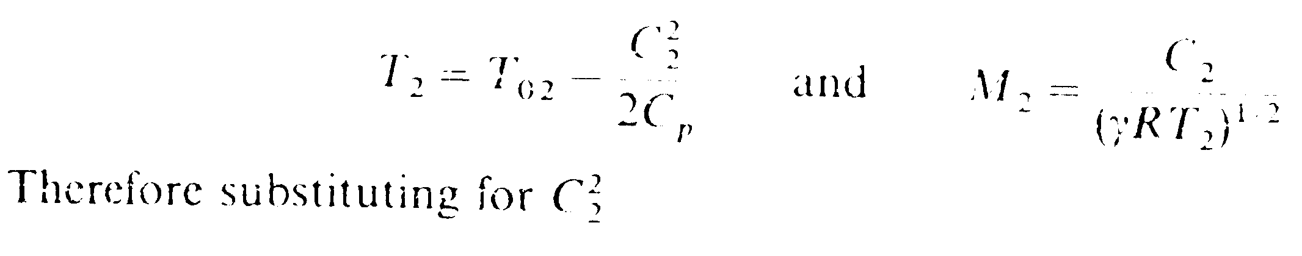
T₂ = 379.3 K
P₂/P_{o2} = 0.5283
P₂ = 232.8 kPa
ρ₂ =2.138 kg/m³
To find the flow velocity normal to the prephery of the impeller
C_{x2}=σ U₂
= 0.9 x 425.75 = 383.2 m/sec
The Mach number is one at exit so
$$C_{2}^{2}={\text{γRT}}_{2}$$
$$C_{2}^{2}=1\text{.}4×\text{287}\text{.}1×\text{379}\text{.}2=\text{152415}\text{.}7$$
$$C_{2}^{2}=C_{\text{x2}}^{2}+C_{\text{r2}}^{2}$$
$$C_{\text{r2}}=\text{74}\text{.}\text{66m/sec}$$
$$A_{2}=\frac{m}{ρ_{2}C_{\text{r2}}}=\frac{8}{2\text{.}\text{138}×\text{74}\text{.}\text{66}}=0\text{.}\text{05012}$$
The impeller depth b at outlet is given by:
$$b=\frac{A_{2}}{{\text{πD}}_{2}}=0\text{.}\text{023545m}$$
5-a)If we compress in a single compression from 1 to 5, the isentropic work done is

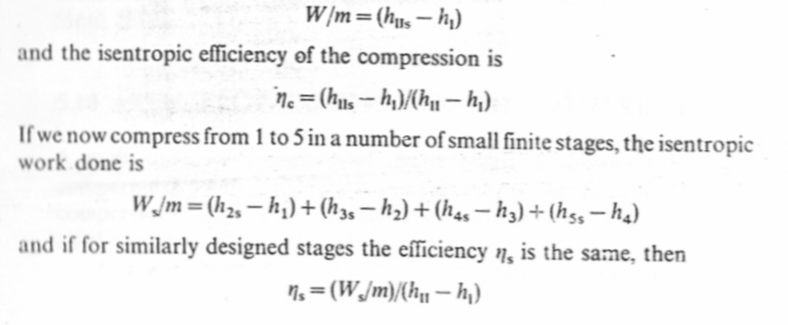

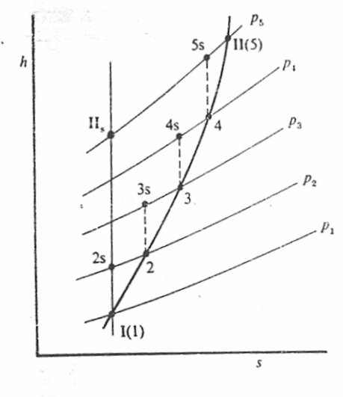

Figure 10
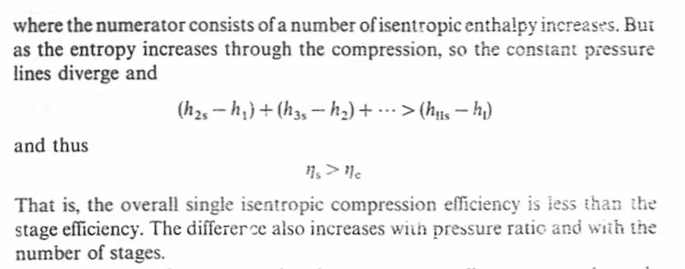

5-b)In a rotor of a turbine or compressor the total relative enthalpy is constant from inlet to outlet i.e.
$$h_{\text{01rel}}=h_{\text{02rel}}\text{.}$$
Then $h_{1}+\frac{W_{1}^{2}}{2}=h_{2}+\frac{W_{2}^{2}}{2}$
Or $h_{1}−h_{2}=\frac{W_{2}^{2}−W_{1}^{2}}{2}$
Across the stage the fluid may be considered as incompressible. Therefore
$p_{\text{01rel}}=p+\frac{{\text{ρW}}_{1}^{2}}{2}$ and $p_{\text{02rel}}=p+\frac{{\text{ρW}}_{2}^{2}}{2}$
Hence $h_{1}−h_{2}=\left(\frac{p_{\text{02rel}}−p}{ρ}\right)−\left(\frac{p_{\text{01rel}}−p}{ρ}\right)$
Now along an isentropic process
$$\text{Tds}=\text{dh}−\frac{1}{ρ}\text{dp}=0$$
Therefore $\text{dh}=\frac{1}{ρ}\text{dp}$
Along 1-2s $h_{\text{2s}}−h_{1}=\frac{p_{2}−p_{1}}{ρ}$
Thus $h_{2}−h_{\text{2s}}=\frac{p_{\text{01rel}}−p−p_{\text{02rel}}+p}{ρ}−\frac{p_{2}−p_{1}}{ρ}$
$h_{2}−h_{\text{2s}}=\frac{p_{\text{01rel}}−p_{\text{02rel}}}{ρ}$

5-c) The reaction ratio R is given by:
$$R=φ({\text{tanβ}}_{1}+{\text{tanβ}}_{2})\text{/2}$$
Where,
$φ=\frac{C_{a}}{U}$
$$U=\text{ωr}=\frac{\text{2πn}}{\text{60}}r$$
$$=\frac{\text{2π}×\text{18000}}{\text{60}}0\text{.}\text{18}=\text{339}\text{.}\text{292m/sec}$$
$$∴φ=0\text{.}\text{530516}$$
$$({\text{tanβ}}_{1}+{\text{tanβ}}_{2})=\frac{\text{2R}}{φ}=1\text{.}\text{8849555}$$
$$∵β_{2}={\text{25}}^{o}→→∴{\text{tanβ}}_{1}=1\text{.}\text{4186}$$
$$∴β_{1}=\text{54}\text{.}{\text{82}}^{o}→→(i)$$
$$α_{2}=β_{1}=\text{54}\text{.}{\text{82}}^{o}$$
$$\overset{˙}{m}={\text{ρC}}_{a}\frac{π}{4}(D_{0}^{2}−D_{i}^{2})$$
$$ρ=\frac{p}{\text{RT}}=1\text{.}\text{18877kg/sec}$$
$$\overset{˙}{m}=1\text{.}\text{18877}×\text{180}×\frac{π}{4}(0\text{.}{\text{42}}^{2}−0\text{.}3^{2})$$
$$=\text{14}\text{.}\text{52kg/sec}→→(\text{ii})$$
Actual Work $={\text{λUC}}_{a}({\text{tanβ}}_{1}−{\text{tanβ}}_{2})=\text{51182J/kg}$
Power required $=\frac{\text{51182}}{ηη}\overset{˙}{m}=\text{904}\text{.}\text{146kW}→→(\text{iii})$
$$ψ=λ({\text{tanα}}_{2}−{\text{tanα}}_{1})$$
$$ψ=0\text{.}\text{4446}$$
$$T_{\text{01}}=T_{1}+\frac{C_{1}^{2}}{{\text{2C}}_{P}}=\text{312}\text{.}\text{62K}$$
$$T_{\text{03}}=\text{363}\text{.}\text{55K}=T_{\text{02}}$$
$$\frac{P_{\text{02}}}{P_{\text{o1}}}=(1+0\text{.}\text{88}(\text{363}\text{.}\text{55}−\text{312}\text{.}\text{62})/{\text{312}}\text{.}\text{62})^{γγ−1}$$
$$\frac{P_{\text{02}}}{P_{\text{o1}}}=1\text{.}\text{598}→→(\text{iv})$$
$$M_{1}=\frac{W_{1}}{a}=\frac{\frac{C_{a}}{{\text{cosβ}}_{1}}}{\sqrt{γRT}}$$
$$M_{1}=0\text{.}\text{91}→→(v)$$

