|  |  |  |
| --- | --- | --- |
| **Benha University**  **Faculty of Engineering- Shoubra**  **Electrical Engineering Department**  **Second Year Communications** | Benha | **Final Term Exam**  **Date: 23-1-2012**  **Selective topics(3)**  **Duration : 3 hours** |

|  |  |
| --- | --- |
| 1. Answer all the following questions | 1. 5 questions each 20 marks |
| 1. Illustrate your answers with sketches when necessary. | 1. Total Mark: 100 Marks |
| 1. The exam. Consists of two pages | 1. The first page |

1-

1. Which multiplexing techniques transmit analog signal and witch transmit digital signals?

FDM and WDM transmit analog signal

TDM transmits digital signal,

1. Which modulation techniques are used to transmit digital data over analog signal?

FSK, ASK, PSK, and QAM modulation

1. Which multiplexing technique is designed to use the high bandwidth capability of fiber optic cable?

WDM

1. In which random access method the station sends a frame whenever it has a frame to send?

Pure ALLOHA

1. In which random access method each station is forced to send only at the beginning of time slot?

Sloted ALLOHA

1. In which method, after the station finds the line idle, it sends its frame immediately. If the line is not idle, it continuously senses the line until it finds it idle?

I-persistent

1. In which method, a station that has a frame to send senses the line. If the line is idle, it sends immediately. If the line is not idle, it waits a random amount of time and then senses the line again?

Nonpersistent

1. In which methods, the stations consult one another to find which station has the right to send?

Controlled access

1. In which method, time is divided into intervals. In each interval, a reservation frame precedes the data frames sent in that interval?

Reservation

1. In which handoff, a mobile station only communicates with one base station?

Soft

1. In which handoff, a mobile station can communicate with two base stations at the same time?

Hard

2-

1. Discuss the goals of multiplexing and spread spectrum.

Multiplexing achieves efficiency

Spread spectrum achieves privacy and anti jamming

1. Mention the difference between synchronous TDM and statistical TDM

In synchronous TDM, each input has a reserved slot in the output frame this can be inefficient if some input lines have no data to send.

In statistical time-division multiplexing, slots are dynamically allocated to improve bandwidth efficiency.

1. Define FHSS and DSSS and explain how each achieves bandwidth spreading.

The frequency hopping spread spectrum (FHSS) technique uses *M* different carrier frequencies that are modulated by the source signal. At one moment, the signal modulates one carrier frequency; at the next moment, the signal modulates another carrier frequency

In DSSS, we replace each data bit with n bits using a spreading code. In other words, each bit is assigned a code of n bits, called chips, where the chip rate is n times that of the data bit

In FHSS a sender and receiver can have privacy. If an intruder tries to intercept the transmitted signal, she can only access a small piece of data because she does not know the spreading sequence to quickly adapt herself to the next hop. The scheme has also an antijamming effect. A malicious sender may be able to send noise to jam the signal for one hopping period (randomly), but not for the whole period.

In DSSS the spread signal can provide privacy if the intruder does not know the code. It can also provide immunity against interference if each station uses a different code.

1. Explain the difference between multiplexing and multiple-access.

Multiplexing is a physical layer technique that combines the loads from low-bandwidth channels and transmits them by using a high-bandwidth link.

Multiple access, on the other hand, is an access method in the data link layer

1. Assume that a voice channel occupies a bandwidth of 4 kHz. We need to multiplex 10 voice channels with guard bands of 500 Hz using FDM. Calculate the required bandwidth.

To multiplex 10 voice channels, we need nine guard bands. The required bandwidth is then

B = (4 KHz) × 10 + (500 Hz) × 9 **= 44.5 KHz**

1. Calculate the QAM modulation required to transmit 1.5 Mbps using 250 KHz channel.

The number of bits per Hz = 1.5x106 / 250 x103 =6 bits/Hz

Then 64 QAM is required.

1. Two channels, one with a bit rate of 190 kbps and another with a bit rate of 180 kbps, are to be multiplexed using pulse stuffing TDM with no synchronization bits. Answer the following questions: What is the size of a frame in bits? What is the frame rate? What is the duration of a frame? What is the data rate?

We need to add extra bits to the second source to make both rates = 190 kbps. Now we have two sources, each of 190 Kbps.

The frame carries 1 bit from each source. Frame size = 1 + 1 = **2 bits.**

Each frame carries 1 bit from each 190-kbps source. Frame rate = **190,000 frames/s.**

Frame duration = 1 /(frame rate) = 1 /190,000 = **5.3** μ**s**.

Output data rate = (190,000 frames/s) × (2 bits/frame) = **380 kbps.** Here the output bit rate is greater than the sum of the input rates (370 kbps) because of extra bits added to the second source.

1. What is the duration of a T-1 line frame? What is the overhead (number of extra bits per second)?

T-1 frame duration = 1/frame rate = 1/8000 = 125 μ**s**

The overhead (number of extra bits per second) = 8000x1 =8000 bps

3-

1. Compare the vulnerable time of pure ALOHA, slotted ALOHA and CSMA.

In pure ALOHA the vulnerable time is two times the frame transmission time

In slotted ALOHA the vulnerable time is the same as the frame transmission time

In CSMA the vulnerable time is the same as the propagation time

1. In a *CDMAlCD* network with a data rate of 10 Mbps, the minimum frame size is found to be 512 bits for the correct operation of the collision detection process. What should be the minimum frame size if we increase the data rate to 100 Mbps? To 1 Gbps? To 10 Gbps?

The minimum frame size is proportional to the data rate

Frame size = K x (data rate)

512 bits = K x (10 Mbps)

? =K x (100Mbps)

Frame size at 100Mbps = 512 bits x (100Mbps/10Mbps) = 5120 bits

Frame size at 1Gbps = 512 bits x (1000Mbps/10Mbps) = 51200 bits

Frame size at 10Gbps = 512 bits x (10000Mbps/10Mbps) = 512000 bits

1. IN the figure shown, the data rate is 10 Mbps, the distance between station A and C is 2000 m, and the propagation speed is 2 x 108 *mls.* Station A starts sending a long frame at time *t1* =0; station C starts sending a long frame at time *t2* =3µS. The size of the frame is long enough to guarantee the detection of collision by both stations. Find:

* The time when station C hears the collision *(t3)*
* The time when station A hears the collision *(t4)*
* The number of bits station A has sent before detecting the collision.
* The number of bits station C has sent before detecting the collision.

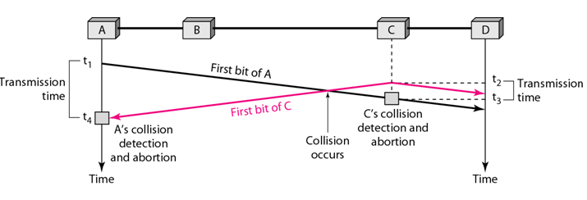

The propagation time (TP) = distance / propagation speed = 2000 m /(2X108 m/s) = 10 µs

The time when station C hears the collision (t3) = t1 + TP = 0 + 10 µs = 10 µs

The time when station A hears the collision (t4) = t2 + TP = 3 µs + 10 µs = 13 µs

The number of bits station A has sent before detecting the collision.= (t4 – t1)x data rate

= (13 µs – 0) x (10 Mbps) = 130 bits

The number of bits station C has sent before detecting the collision.= (t3 – t2)x data rate

= (10 µs – 3 µs) x (10 Mbps) = 70 bits

1. In CDMA what is the result of multiplying each code by another and by itself?

If we multiply each code by another, we get 0.

If we multiply each code by itself, we get the number of stations.

1. Calculate the Walsh table *W2* and *W4 using W1 =* [-1]

W1 = [-1]

W2 =

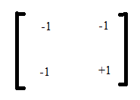

W4 =

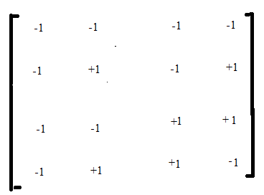

4-

1. Briefly describe the GSM network subsystems.

A GSM network is split into three subsystems which are described in more detail below:

• The base station subsystem (BSS), which is also called ‘radio network’, contains all nodes and functionalities that are necessary to wirelessly connect mobile subscribers over the radio interface to the network. The radio interface is usually also referred to as the ‘air interface’.

• The network subsystem (NSS), which is also called ‘core network’, contains all nodes and functionalities that are necessary for switching of calls, for subscriber management and mobility management.

• The intelligent network subsystem (IN) comprises SCP databases which add optional functionality to the network.

1. Which access methods are used in GSM?

FDMA and TDMA

1. Explain the difference between FDD and TDD

In FDD, a pair of simplex channels with a fixed and known frequency separation is used to define a specific radio channel in the system. FDD is used exclusively in analog mobile radio systems

Time division duplex (TDD) uses the fact that it is possible to share a single radio channel in time, so that a portion of time is used to transmit from the base station to the mobile, and the remaining time is used to transmit from the mobile to the base station. TDD is only possible with digital transmission

1. Define the forward channel and the reverse channel.

The channel used to convey traffic to the mobile user from a base station is called the forward channel, while the channel used to carry traffic from the mobile user to a base station is called the reverse channel.

1. Explain the steps to determine the co channel cells. Give an example.

To determine the co channel cells

* Move i cells along any shape of hexagons
* Turn 60 degrees counter clockwise
* Move j cells

An example for N=19 i=3 and j=2 the following figure illistrates the determination of the co channel of A cells

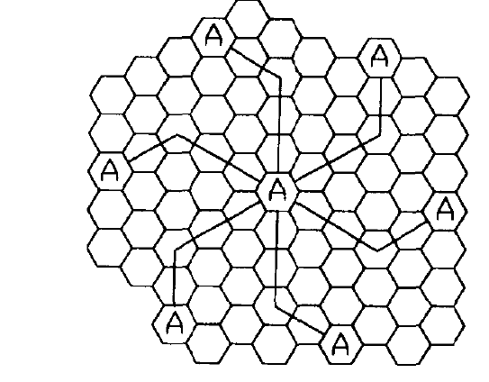

1. A GSM cellular system uses a frequency band of 890MHz – 960MHz and a channel bandwidth of 200 KHz. Compute the number of channels available per cell if the system uses a 7-cell reuse.

Total available channels = (960 MHz -890 MHz)//200KHz = 350 channel.

Number of channels available per cell = 350/7 = 50 channel.

5-

1. Explain the advantage of dynamic channel assignment over fixed channel assignment.

Dynamic channel assignment reduces the likelihood of blocking, which increases the trunking capacity.

1. Explain the SS-7 protocol stack compared to OSI model and TCP/IP model

The SS-7 Protocol Stack comprises a number of protocols and layers as shown compared to OSI model and TCP/IP model.

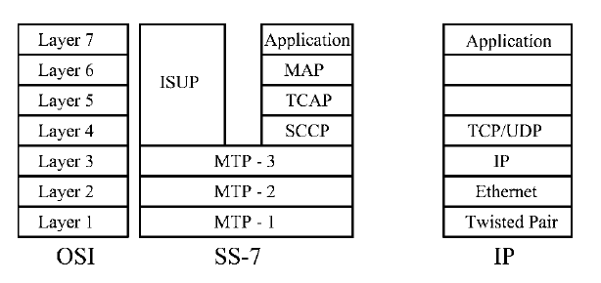

**The message transfer part 1 (MTP-1) protocol** describes the physical properties of the transmission medium on layer 1 of the OSI model. Properties that are standardized in MTP-1 are for example the definition of the different kinds of cables that can be used to carry the signal, signal levels, and transmission speeds.

**MTP-2 protocol** inlayer 2, the data link layer, messages are framed into packets and a start and stop identification at the beginning and end of each packet is inserted into the data stream so the receiver is able to detect where a message ends and a new message begins.

**The MTP-3 protocol** uses so-called point codes to identify the source and the destination of a message.

**ISDN user part (ISUP) protocol** is used when a call is established between two parties, party A is a mobile subscriber while party B is a fixed-line subscriber

1. Mention the relation of the co-channel reuse ratio and the cluster size. Explain its effect on the system capacity and transmission quality.

Q= D/R = $\sqrt{3N}$

The small value of Q provides larger capacity since the cluster size N is small, whereas a large value of Q improves the transmission quality due to a smaller value of co channel interference

1. If a signal to interference ratio of 15 dB is required for satisfactory forward channel performance of a cellular system. Assume the pass loss exponent is 3and there is 6 co-channel cells. What is the frequency reuse and the cluster size that should be used for maximum capacity.

S/I = ()n /IO

For i=1 and j=2 then N= 7

S/I = ()3 /6 = 16.03 =12,05 dB less than 15 dB

For i=2 and j=2 then N= 12

S/I = ()3 /6 = 36 =15,56 dB more than 15 dB

Then N= 12 can be used

1. Define the adjacent channel interference and explain how it can be minimized.

Adjacent channel interference resulting from signals which are adjacent in frequency to the desired signal. It results from imperfect receiver filter.

Adjacent channel interference can be minimized carful filtering and channel assignments.

1. Explain the purpose of te following protocols : SCCP, MAP, and BSSMAP

**(SCCP)** the **signaling connection and control part** is used on layer 4 in SS-7 world, to forward incoming messages to the right application using **subsystem numbers (SSNs).**

**(MAP) the mobile application part)**: this protocol is used for the communication between an MSC and the home location register (HLR)

**(BSSMAP) the base station subsystem mobile application part**: this protocol is used for the communication between the MSC and the radio network.

**Dr. Adly Tag Eldien**