A sudden visit to Kafr-Saad

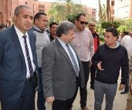
Prof.Dr. El-Sayed El-Kady, the university president suddenly visits the university’s students in the university hostel in Kafr-Saad and listens to the complaints of the students and the employees in the university hostel. The university president was accompanied by Wahid Khalawy, the secretary of the university.

