Terrorism will never terrify Egyptians and Egypt will not be defeated

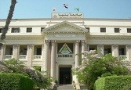
Benha University sadly receives the two pieces of news of the terrorist attacks on the church Mary Gerges in Tanta and the church of Mary Morkos in Alexandria which result in many causalities and the death of many Egyptians, but Terrorism will never terrify Egyptians and Egypt will never be defeated as the Egyptians will always stand firm and united against these mean incidents.

